**LAB1**

**Big Data Analytics**

**Muskan**

**12212062**

**CS A4**

**Analyze the effect of different windowing techniques on processing of data streams. For this**

**purpose perform the following steps:**

**a. Download and install open source Jupyter Notebook or any other Python IDE of your choice**

**b. Download any sensor based numeric datasets from UCI Machine Learning Repository or from**

[**www.kaggle.com**](http://www.kaggle.com/)**. Consider the data sequentially to mimic streaming behavior of data.**

**c. Extract the different data windows using a windowing technique**

**d. Perform clustering using k-means algorithm on different data windows**

**e. Iterate Step c. and d. for different window sizes**

**f.**

**Iterate over step c. to e. using different windowing technique**

**g. Draw the plots and state your observations in context of effect of window size and windowing**

**techniques on the clustering performance in terms of different clustering metrics.**

**DATASET2.CSV from the bending2 folder is being used.**

**import pandas as pd**

**import time**

**# Update file path as per your system**

**dataset_path = "/Users/muskan/deeplearning/bda/dataset2.csv"**

**df = pd.read_csv(dataset_path, skiprows=4)**

**print("Dataset loaded successfully.")**

**print(df.head())**

**#(b) Function to simulate streaming data**

**def simulate_streaming_data(data, delay=0.5):**

**"""**

**Simulates streaming data by yielding one row at a time.**

**Parameters:**

**data (pd.DataFrame): The input dataset.**

**delay (float): Time delay (in seconds) between each row emission.**

**"""**

**for index, row in data.iterrows():**

**print(f"\nStreaming row {index + 1} of {len(data)}:")**

**print(row.to_dict()) # Display the row data as a dictionary**

**yield row**

**time.sleep(delay) # Simulate delay between streams**

**# Simulate streaming the dataset**

**print("\nSimulating data stream...")**

**for streamed_row in simulate_streaming_data(df, delay=0.5):**

**# Process the streamed row here (e.g., perform analysis or pass to a model)**

**pass**

**#(c) Extract the different data windows using a windowing technique**

**import pandas as pd**

**def sliding_window(data, window_size, stride):**

**"""**

**Generate sliding windows from the dataset.**

**Parameters:**

**data (pd.DataFrame): The dataset.**

**window_size (int): The size of each window.**

**stride (int): The step size to move the window.**

**Returns:**

**List of sliding windows as DataFrames.**

**"""**

**windows = []**

**for i in range(0, len(data) - window_size + 1, stride):**

**windows.append(data.iloc[i:i + window_size])**

**return windows**

**def tumbling_window(data, window_size):**

**"""**

**Generate tumbling windows from the dataset.**

**Parameters:**

**data (pd.DataFrame): The dataset.**

**window_size (int): The size of each window.**

**Returns:**

**List of tumbling windows as DataFrames.**

**"""**

**windows = []**

**for i in range(0, len(data), window_size):**

**windows.append(data.iloc[i:i + window_size])**

**return windows**

**# Parameters**

**window_size = 5**

**stride = 2**

**# Extract sliding windows**

**sliding_windows = sliding_window(df, window_size, stride)**

**print(f"Sliding Windows (window size={window_size}, stride={stride}):")**

**for i, window in enumerate(sliding_windows):**

**print(f"\nWindow {i + 1}:\n{window}")**

**# Extract tumbling windows**

**tumbling_windows = tumbling_window(df, window_size)**

**print(f"\nTumbling Windows (window size={window_size}):")**

**for i, window in enumerate(tumbling_windows):**

**print(f"\nWindow {i + 1}:\n{window}")**

**#(d)Perform clustering using k-means algorithm on different data windows**

**import pandas as pd**

**from sklearn.cluster import KMeans**

**from sklearn.preprocessing import StandardScaler**

**import matplotlib.pyplot as plt**

**# Extract sliding windows (from the previous step)**

**def sliding_window(data, window_size, stride):**

**windows = []**

**for i in range(0, len(data) - window_size + 1, stride):**

**windows.append(data.iloc[i:i + window_size])**

**return windows**

**# Parameters**

**window_size = 5**

**stride = 2**

**sliding_windows = sliding_window(df, window_size, stride)**

**# Preprocess data (scaling for clustering)**

**scaler = StandardScaler()**

**# Perform clustering on each window**

**cluster_results = []**

**num_clusters = 3 # Number of clusters for k-means**

**for i, window in enumerate(sliding_windows):**

**# Scale the data**

**scaled_data = scaler.fit_transform(window)**

**# Apply K-means**

**kmeans = KMeans(n_clusters=num_clusters, random_state=42, n_init=10)**

**kmeans.fit(scaled_data)**

**# Store cluster labels and centroids**

**cluster_results.append({**

**"window_index": i,**

**"labels": kmeans.labels_,**

**"centroids": kmeans.cluster_centers_,**

**"inertia": kmeans.inertia_ # Within-cluster sum of squares**

**})**

**# Visualize clustering results**

**for result in cluster_results:**

**print(f"Window {result['window_index'] + 1}:\nCluster Labels: {result['labels']}\n")**

**print(f"Cluster Centroids:\n{result['centroids']}\n")**

**print(f"Inertia (within-cluster sum of squares): {result['inertia']}\n")**

**# Visualize inertia (clustering performance across windows)**

**inertias = [result['inertia'] for result in cluster_results]**

**plt.plot(range(1, len(sliding_windows) + 1), inertias, marker='o')**

**plt.title("K-means Clustering Inertia Across Windows")**

**plt.xlabel("Window Index")**

**plt.ylabel("Inertia")**

**plt.show()**

**# Draw the plots and state your observations in context of effect of window size and windowing**

**#techniques on the clustering performance in terms of different clustering metrics**

**from sklearn.metrics import silhouette_score**

**import numpy as np**

**# Parameters**

**num_clusters = 3**

**silhouette_scores = []**

**inertias = []**

**# Perform clustering for different window sizes**

**for i, window in enumerate(sliding_windows):**

**scaled_data = scaler.fit_transform(window)**

**# Apply K-means**

**kmeans = KMeans(n_clusters=num_clusters, random_state=42, n_init=10)**

**kmeans.fit(scaled_data)**

**# Calculate inertia and silhouette score**

**inertias.append(kmeans.inertia_)**

**if len(window) > 1: # Silhouette score requires at least 2 data points per cluster**

**score = silhouette_score(scaled_data, kmeans.labels_)**

**silhouette_scores.append(score)**

**else:silhouette_scores.append(np.nan)**

**# Plot inertia**

**plt.figure(figsize=(12, 5))**

**plt.subplot(1, 2, 1)**

**plt.plot(range(1, len(sliding_windows) + 1), inertias, marker='o')**

**plt.title("Inertia Across Windows")**

**plt.xlabel("Window Index")**

**plt.ylabel("Inertia")**

**# Plot silhouette score**

**plt.subplot(1, 2, 2)**

**plt.plot(range(1, len(sliding_windows) + 1), silhouette_scores, marker='o', color='orange')**

**plt.title("Silhouette Score Across Windows")**

**plt.xlabel("Window Index")**

**plt.ylabel("Silhouette Score")**

**plt.tight_layout()**

**plt.show()**

**OUTPUT**

**STREAMING DATA STREAMS…**

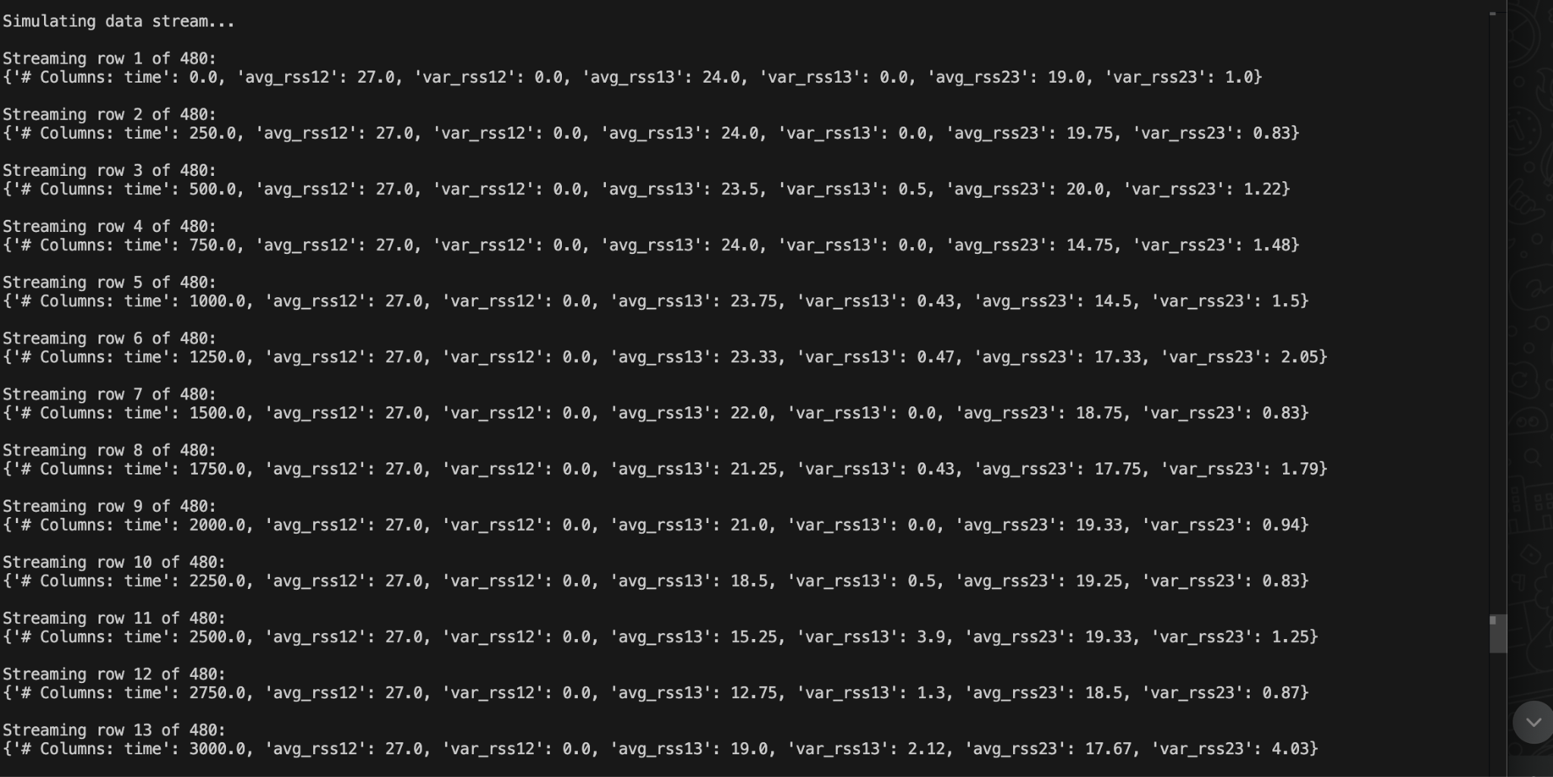

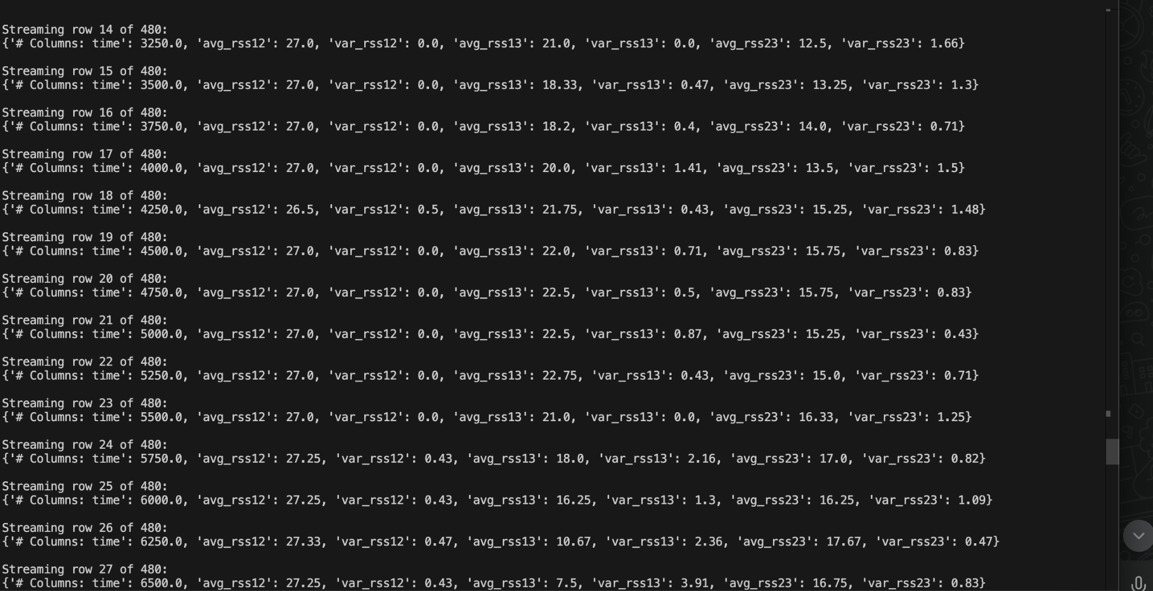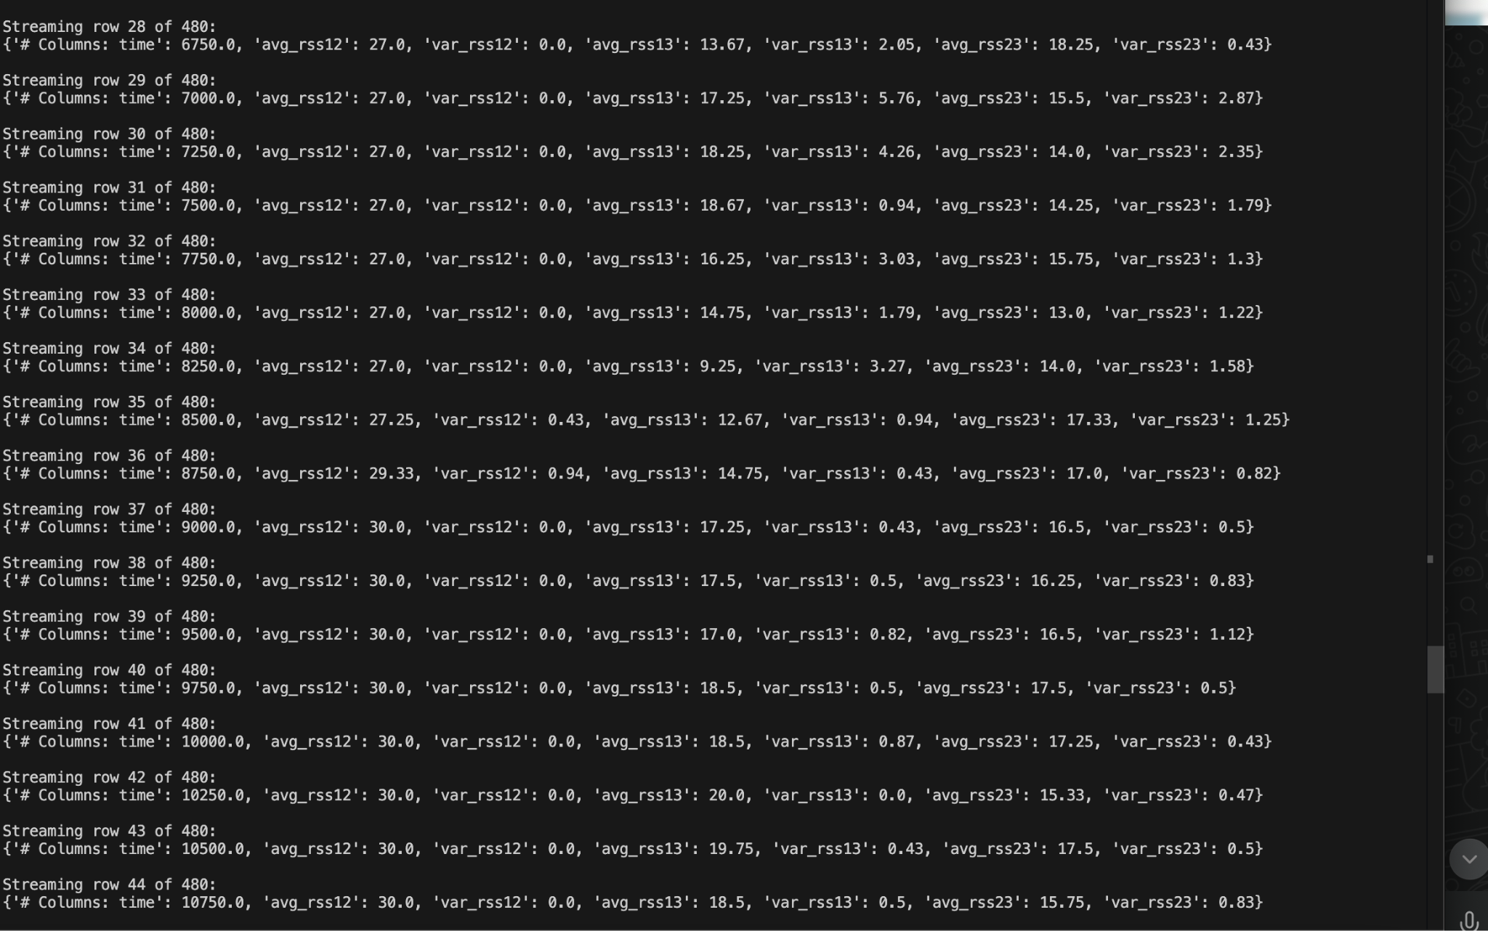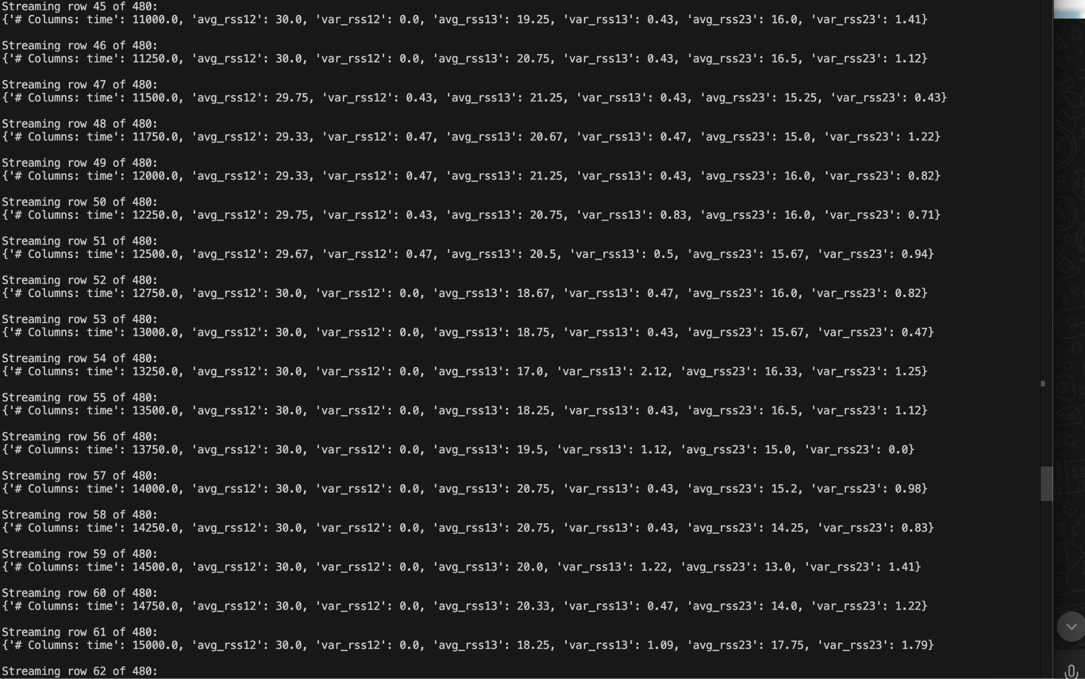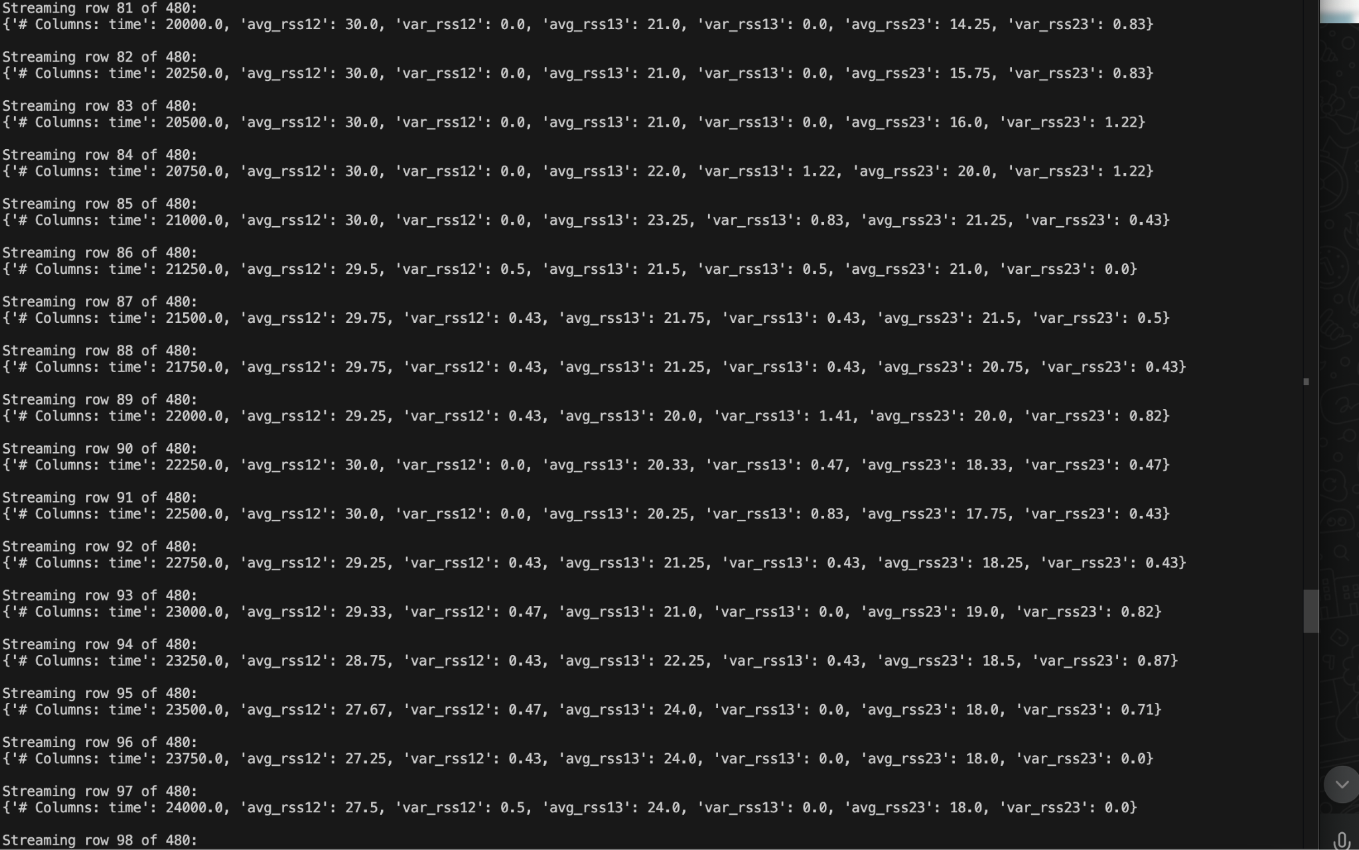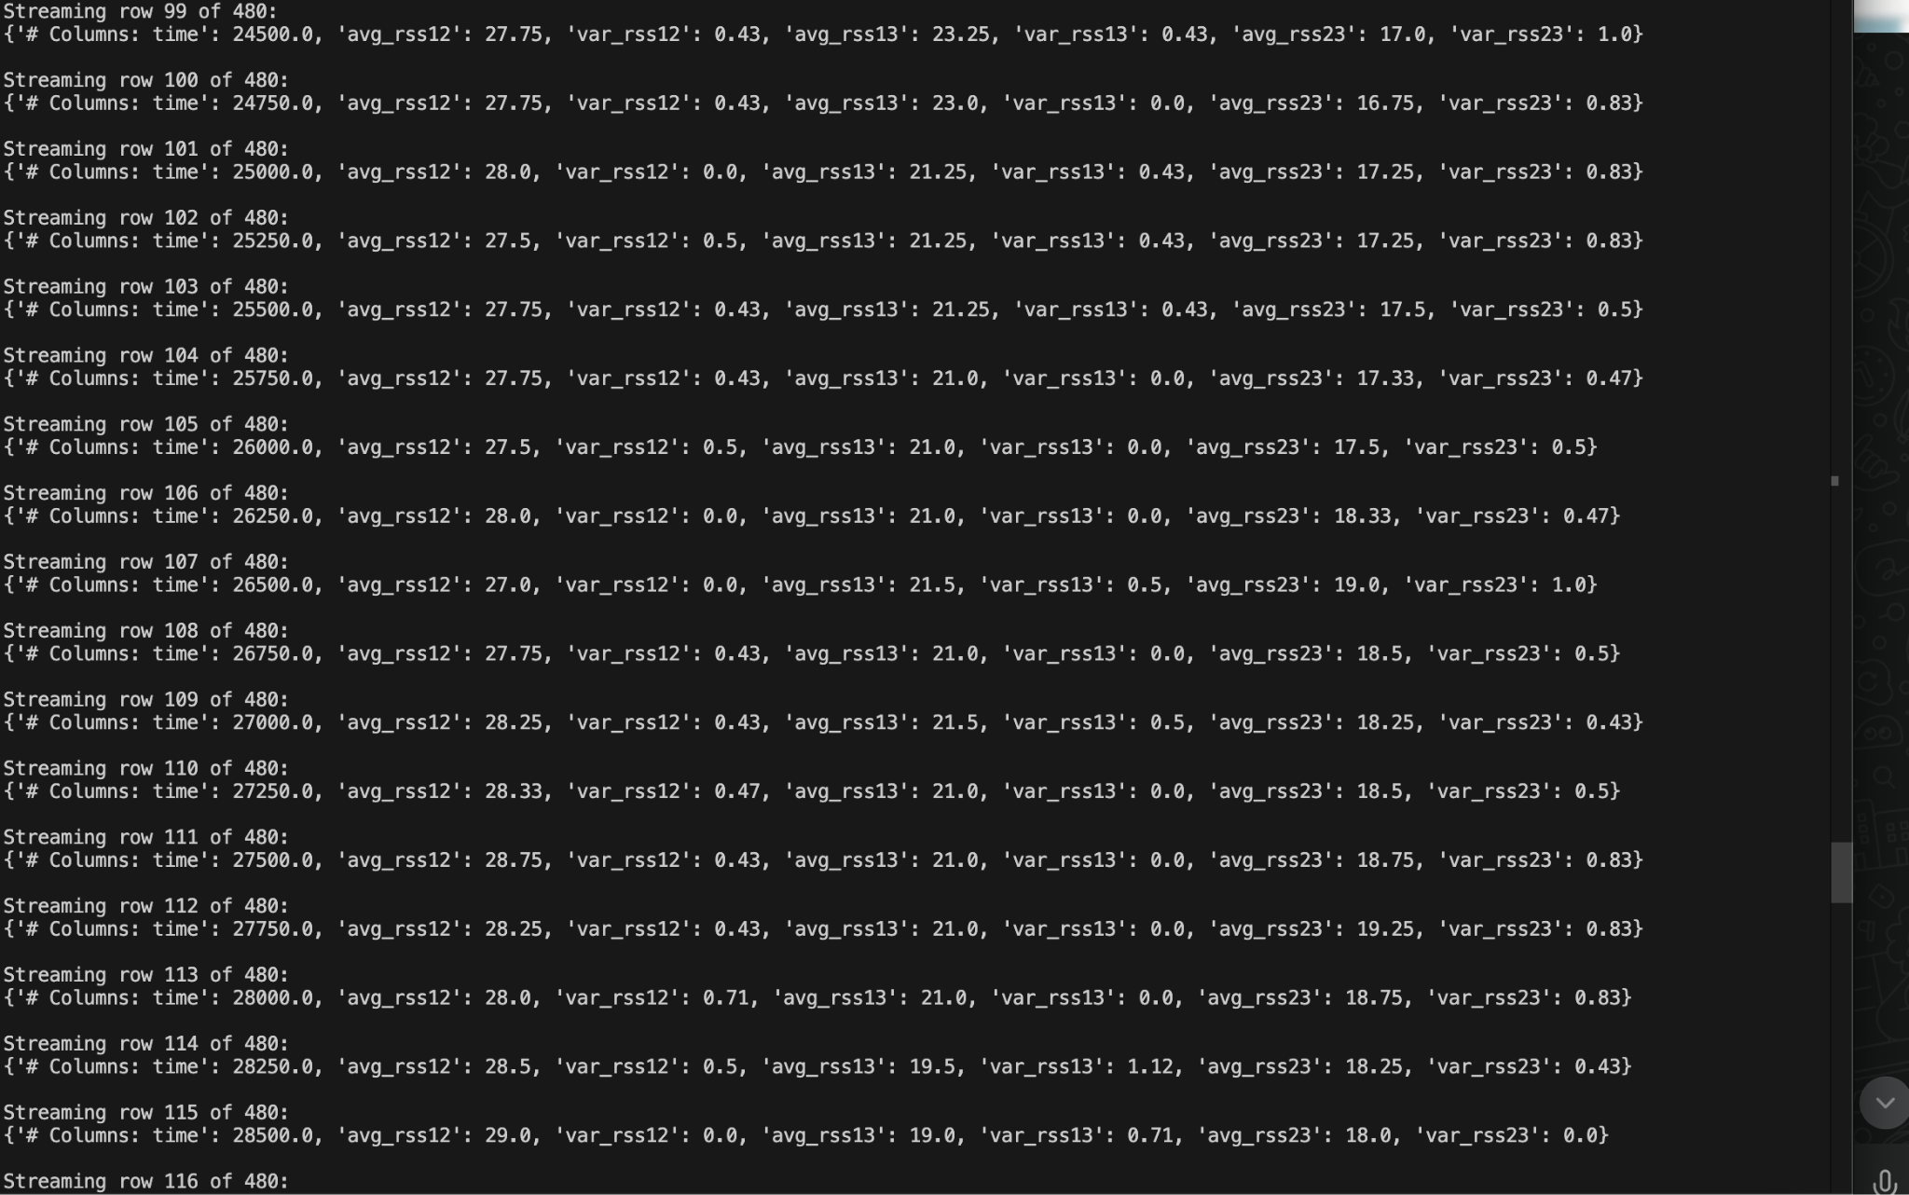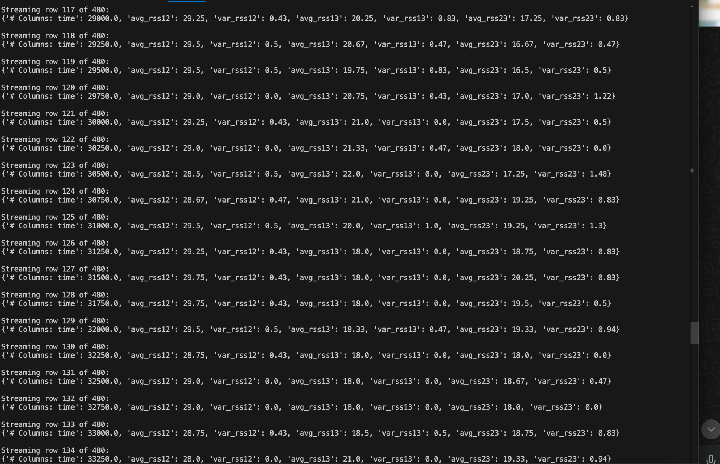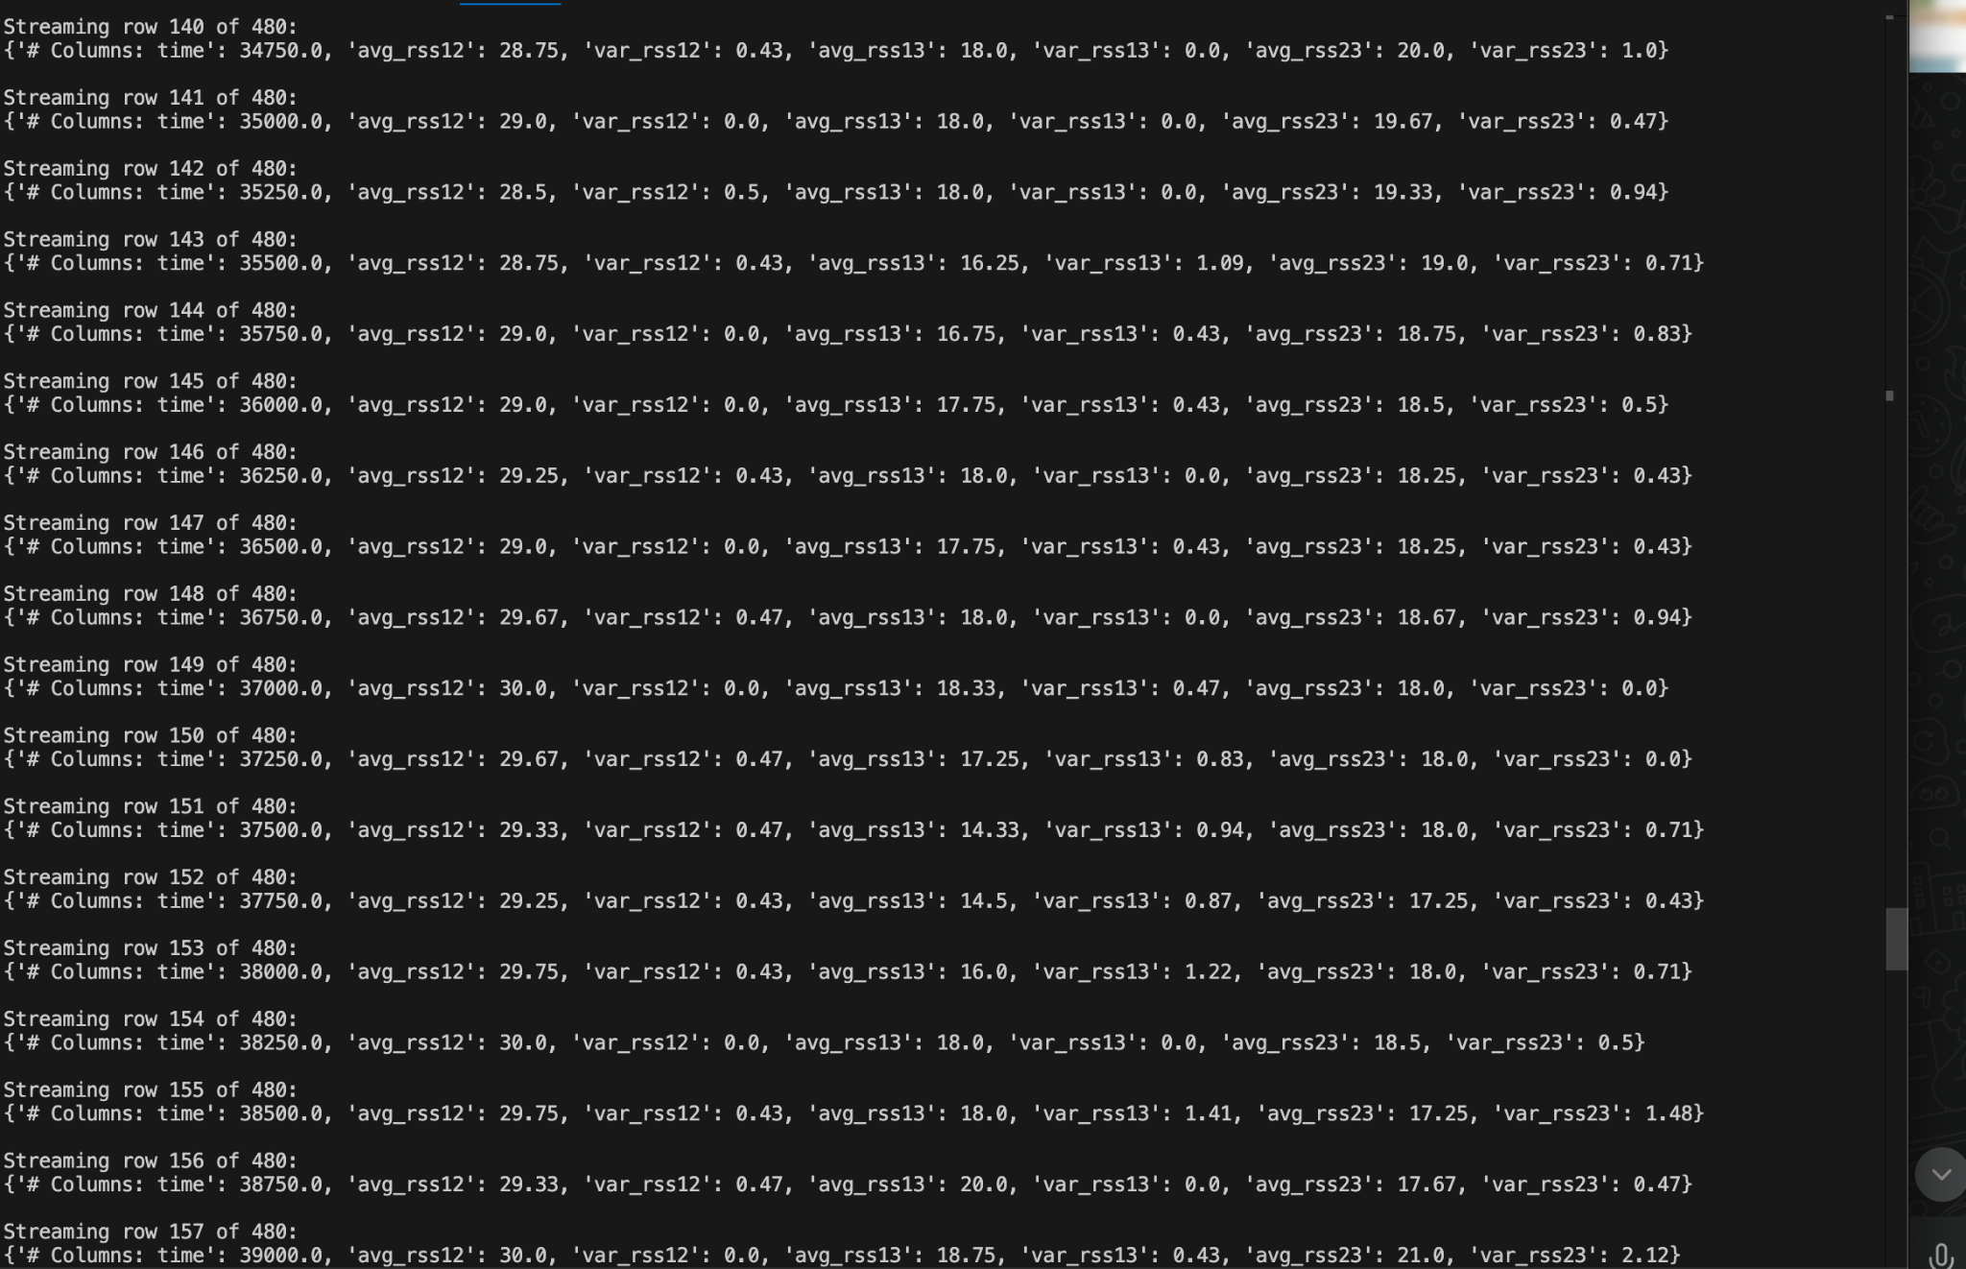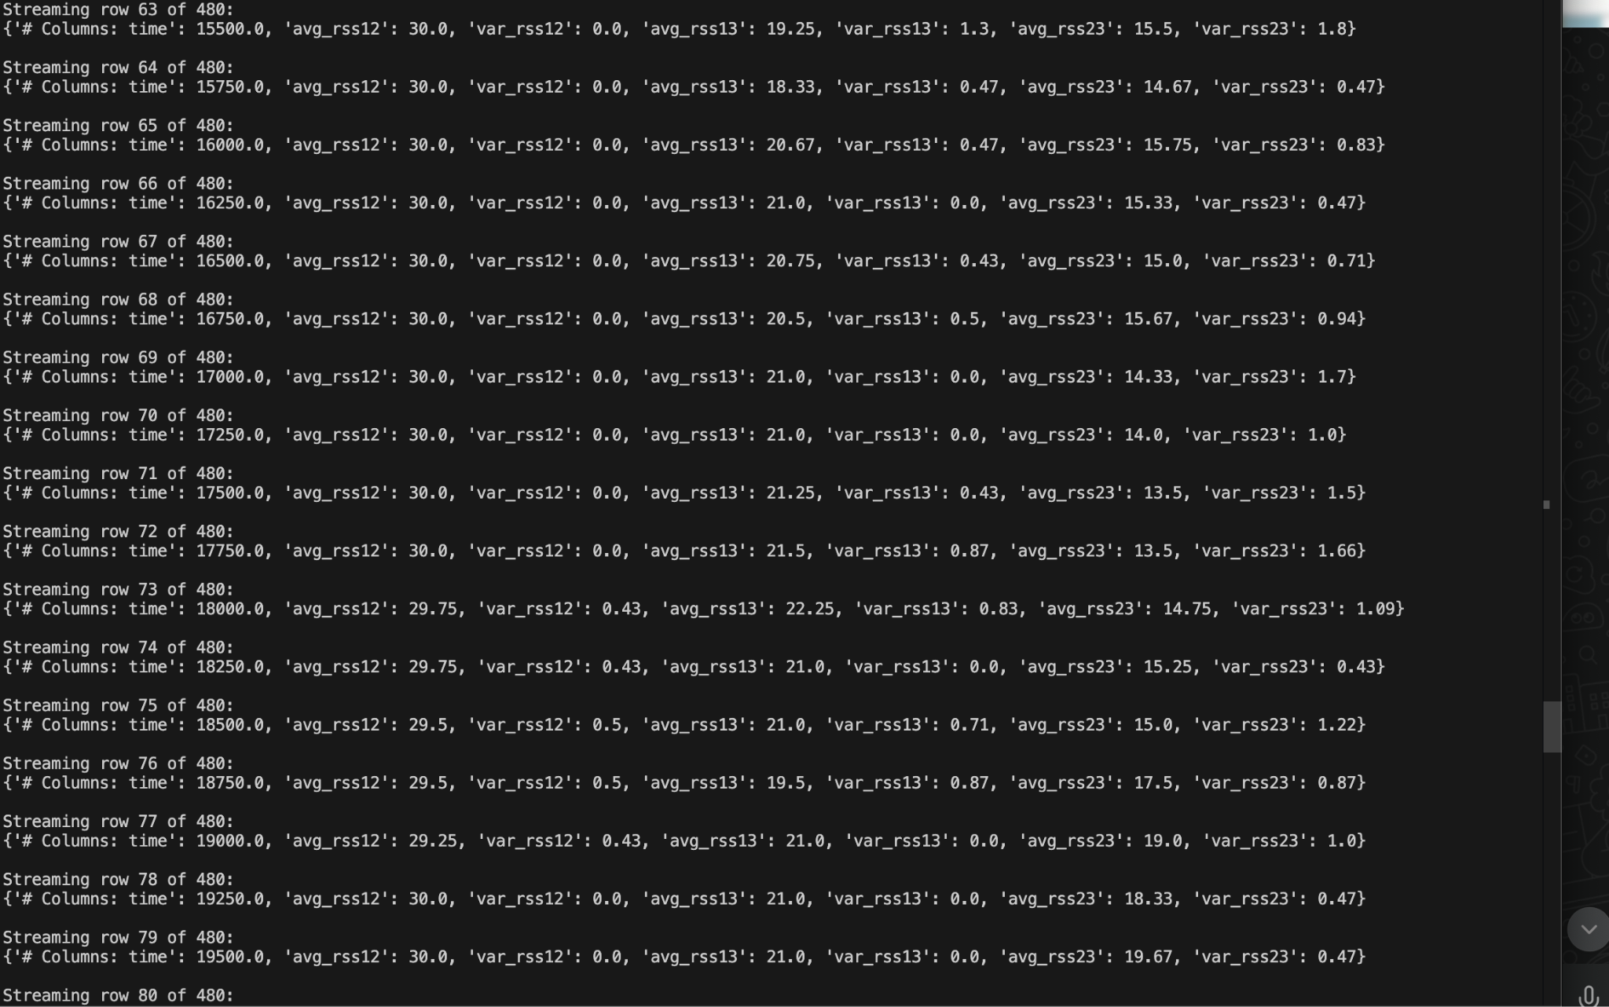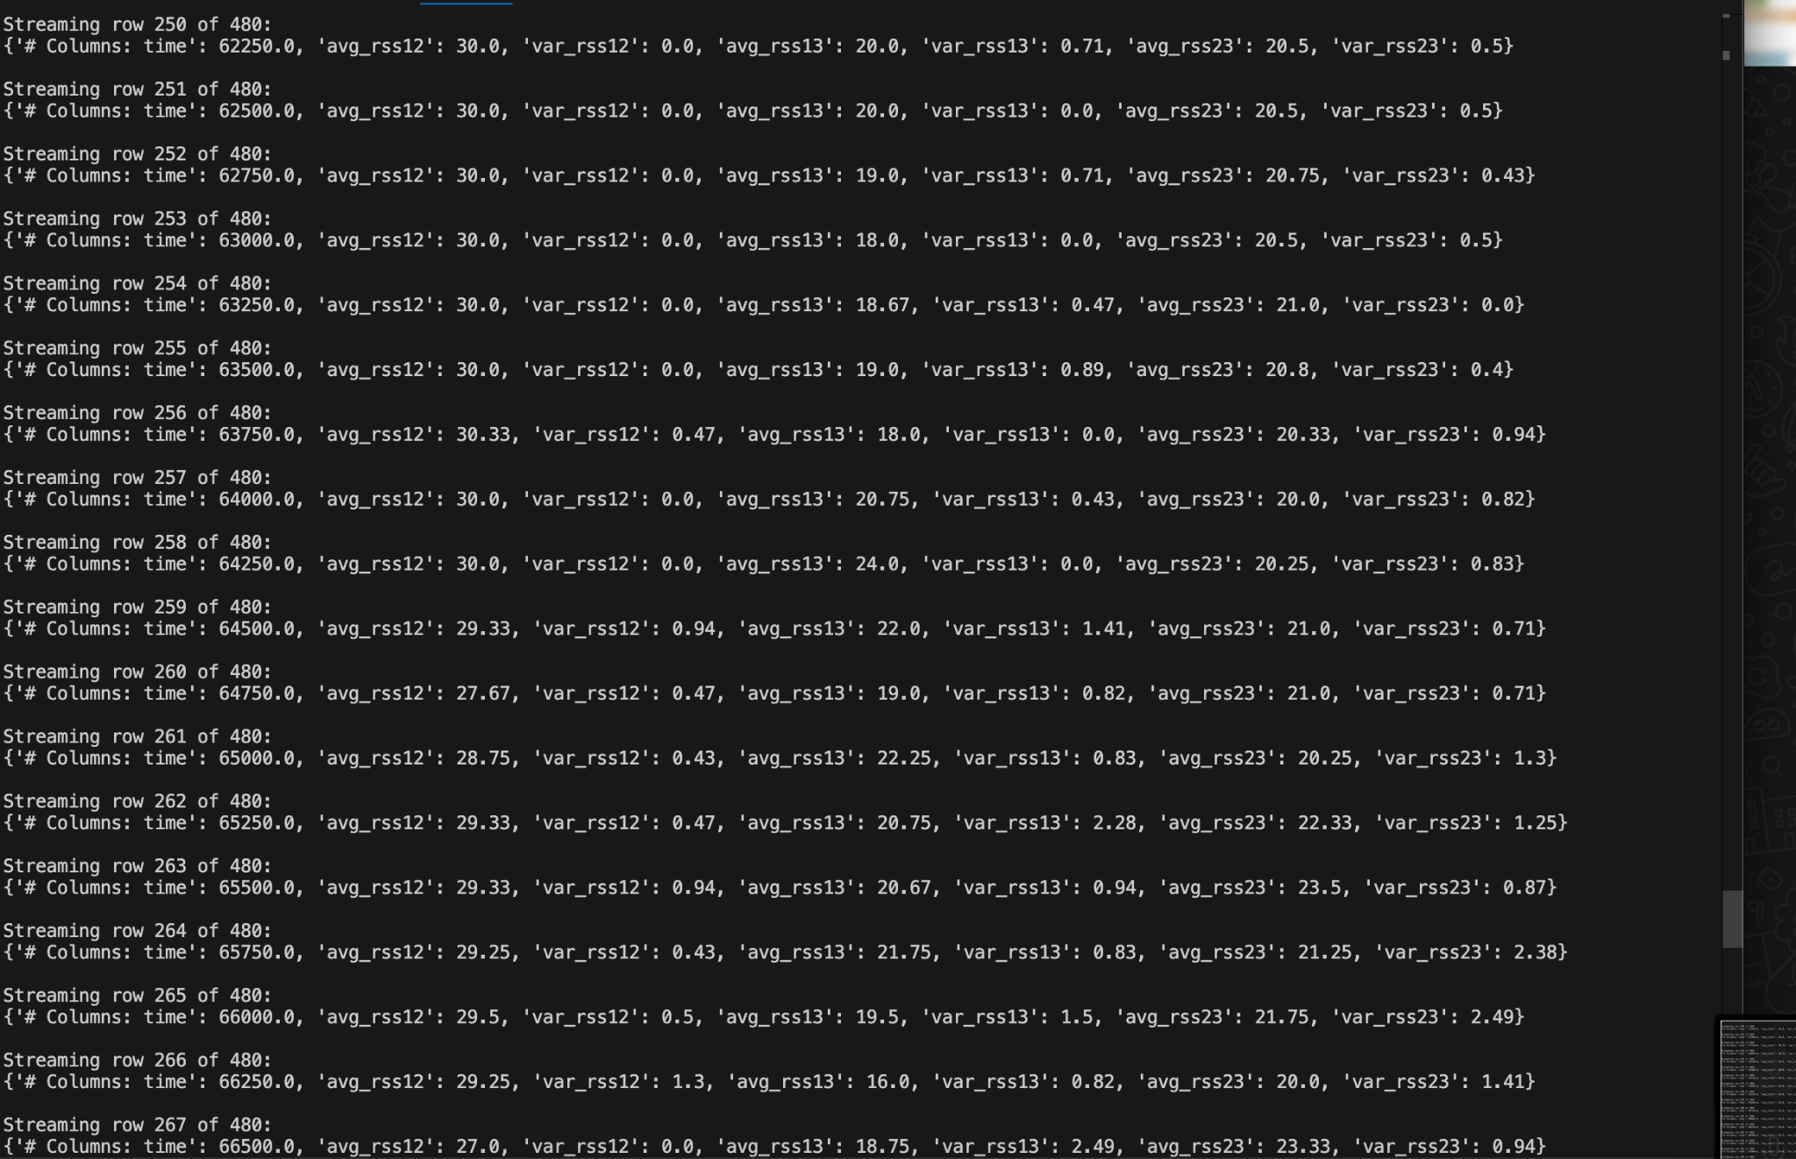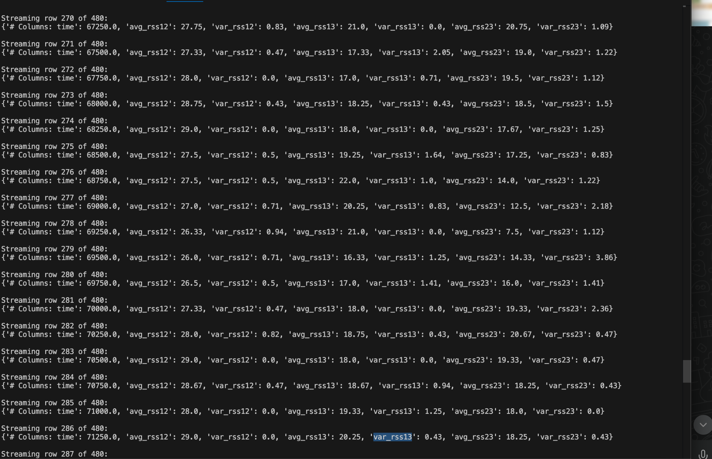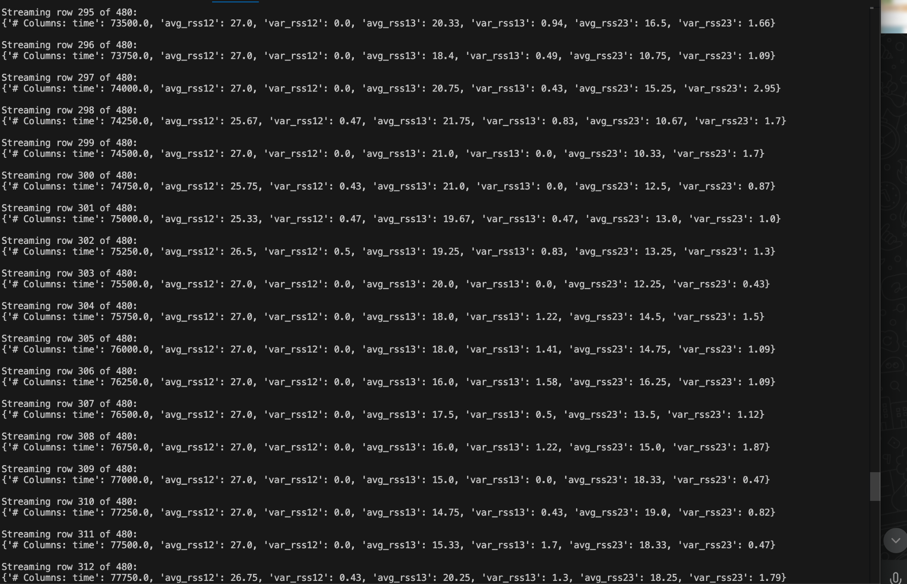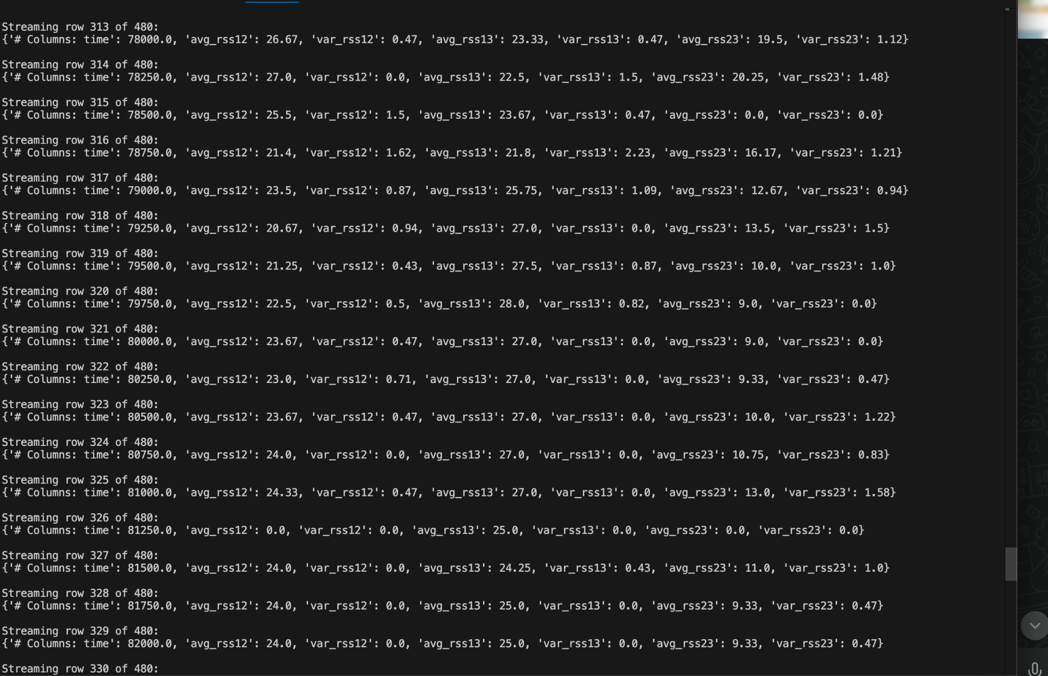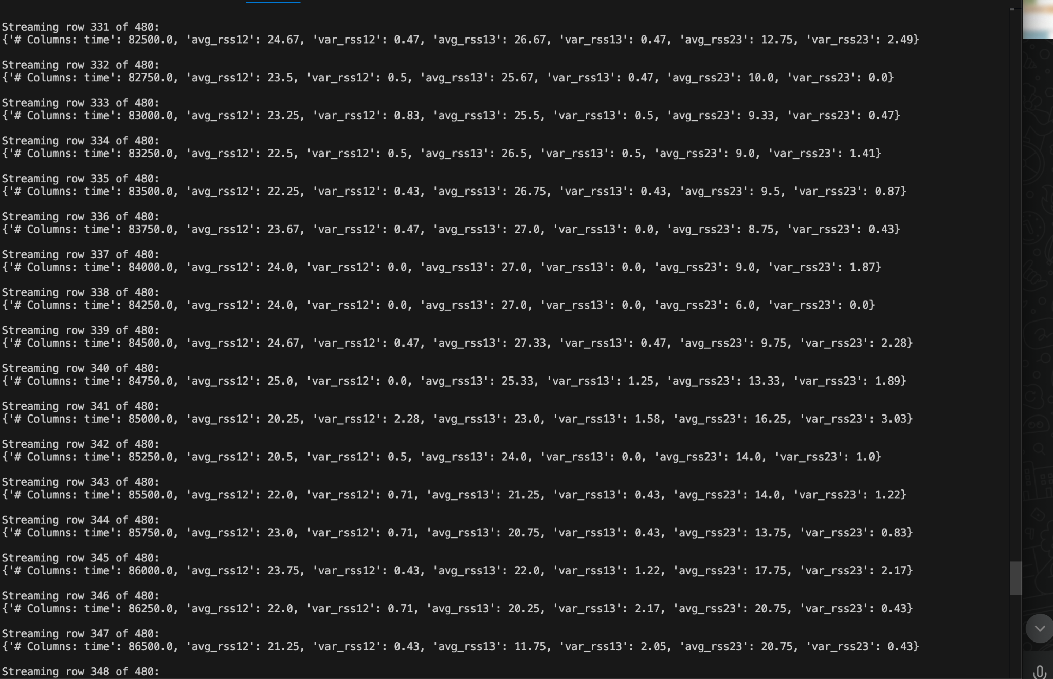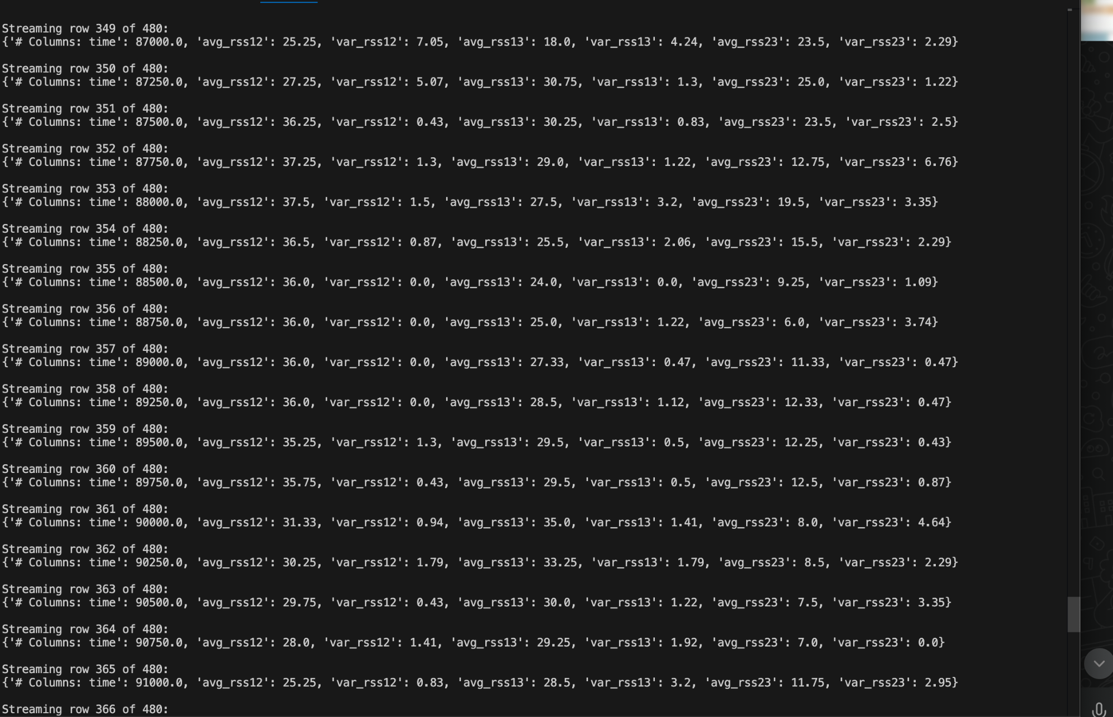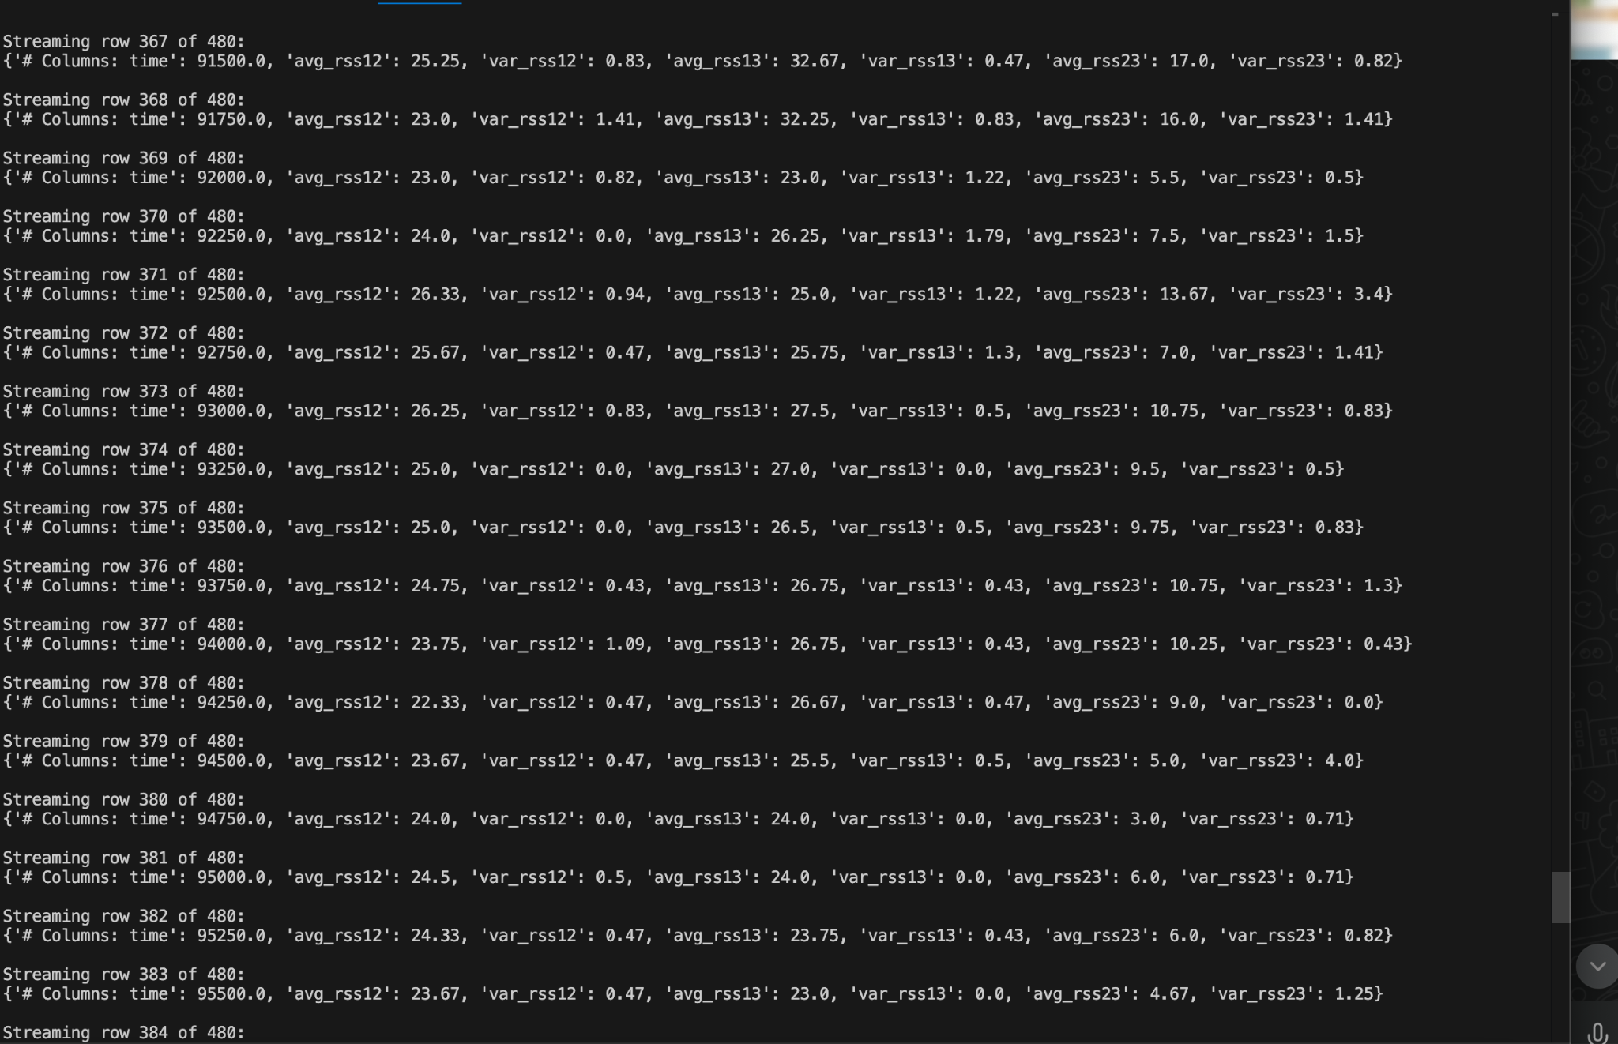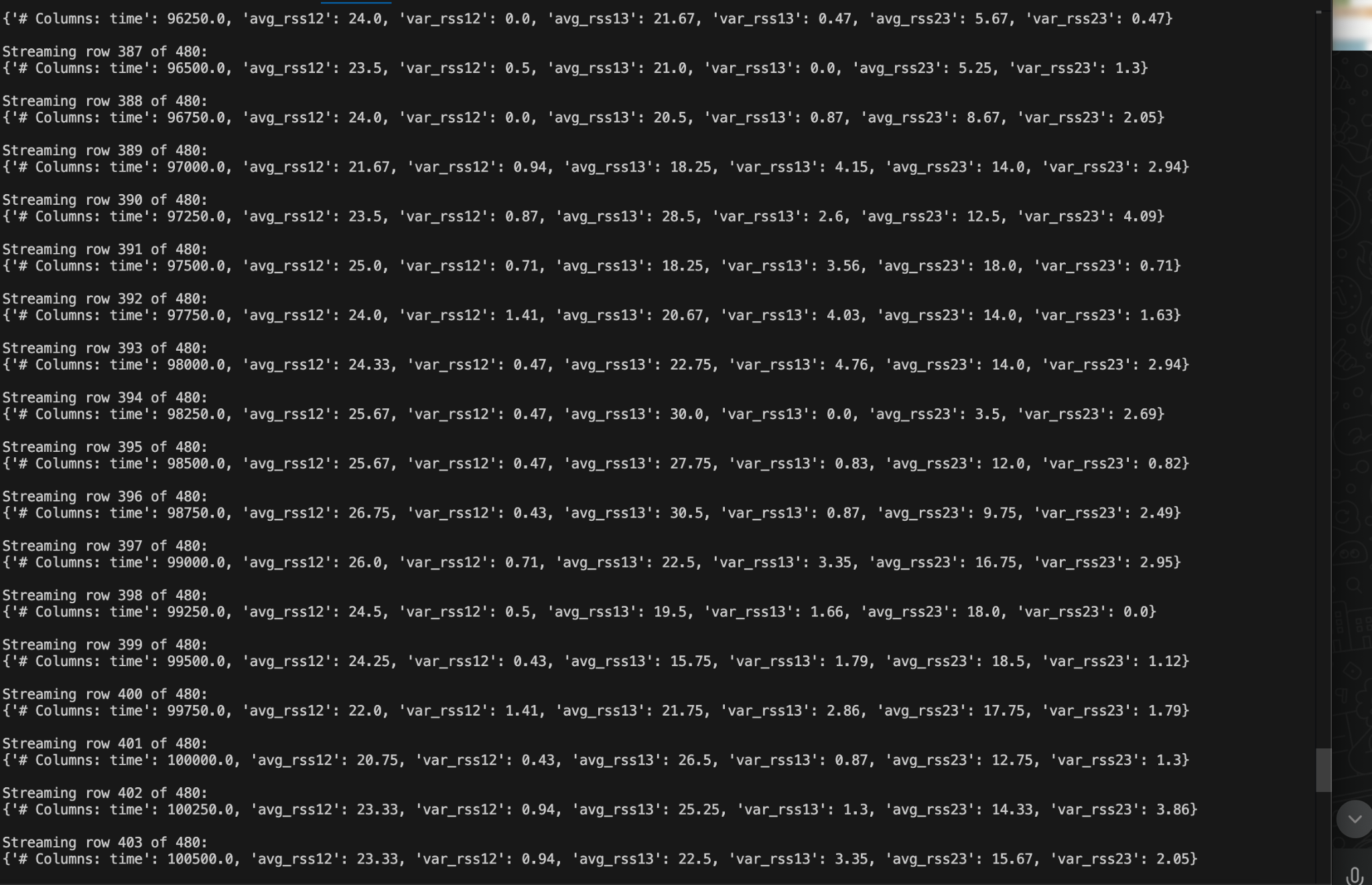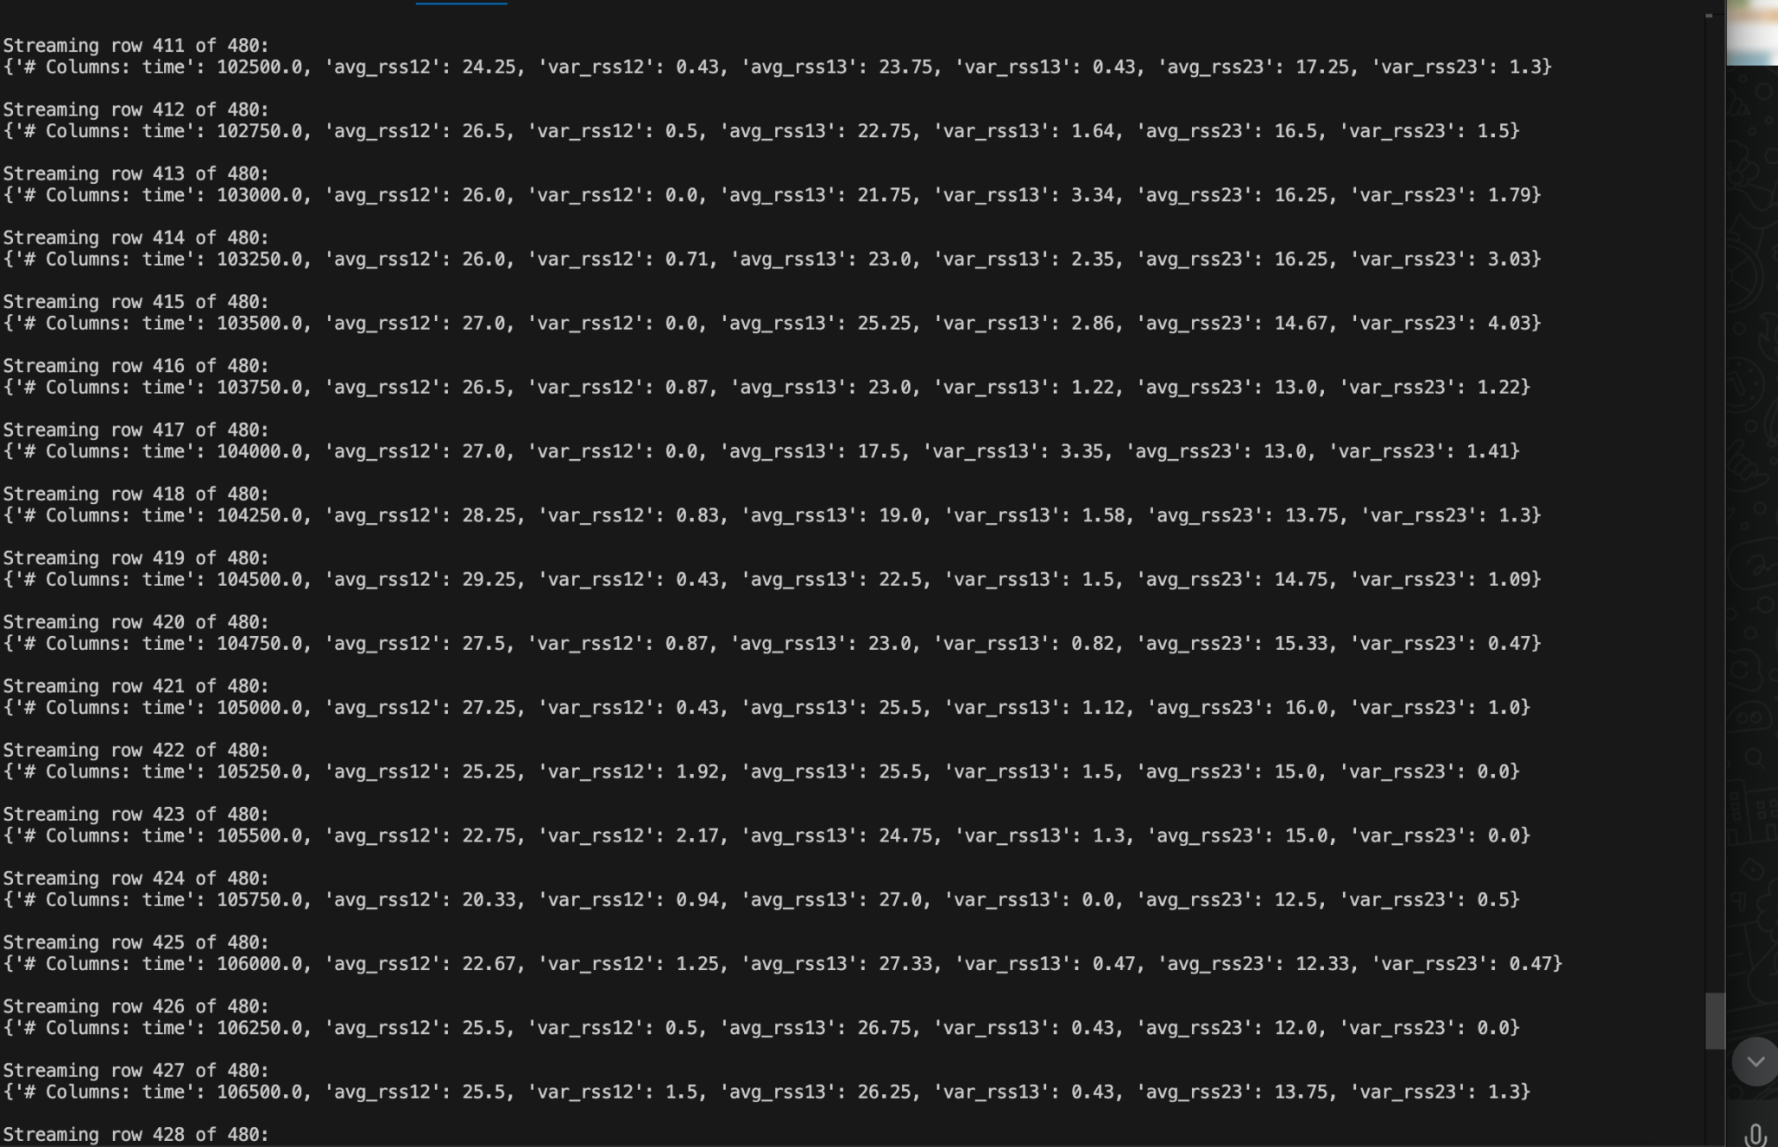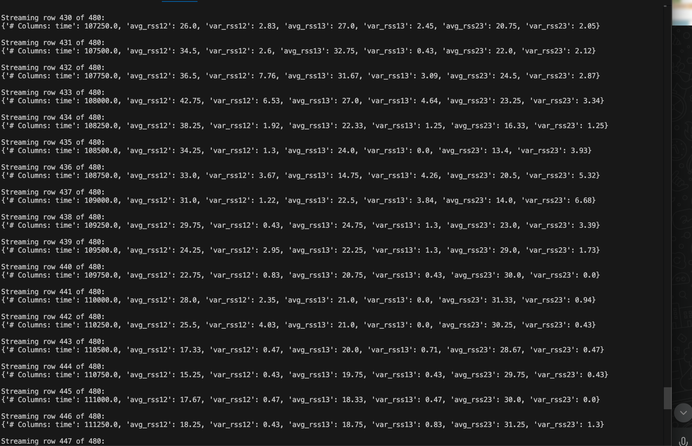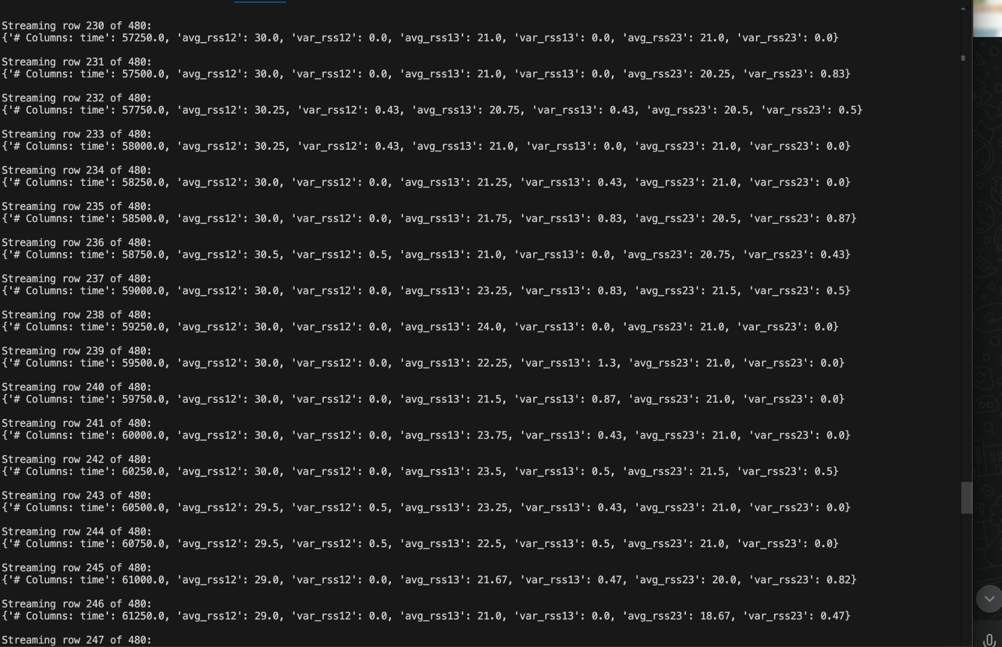

**DIFFERENT DATA WINDOWS USING WINDOWING TECHNIQUE**

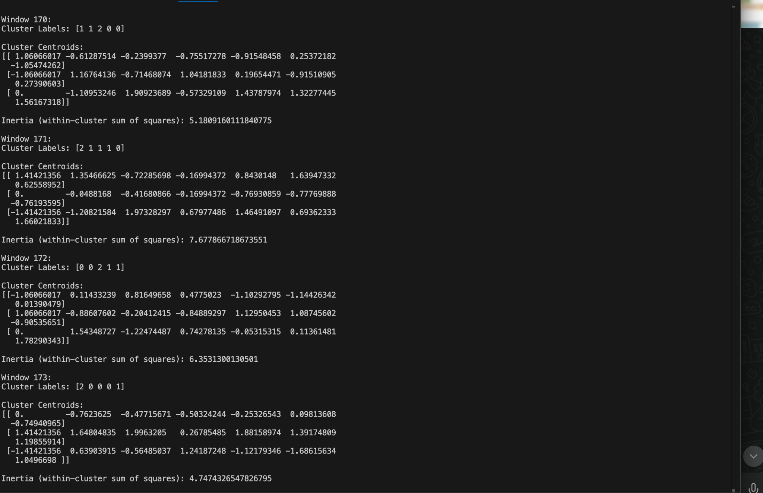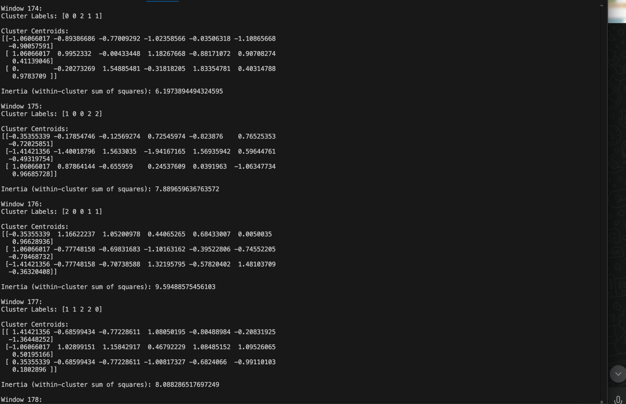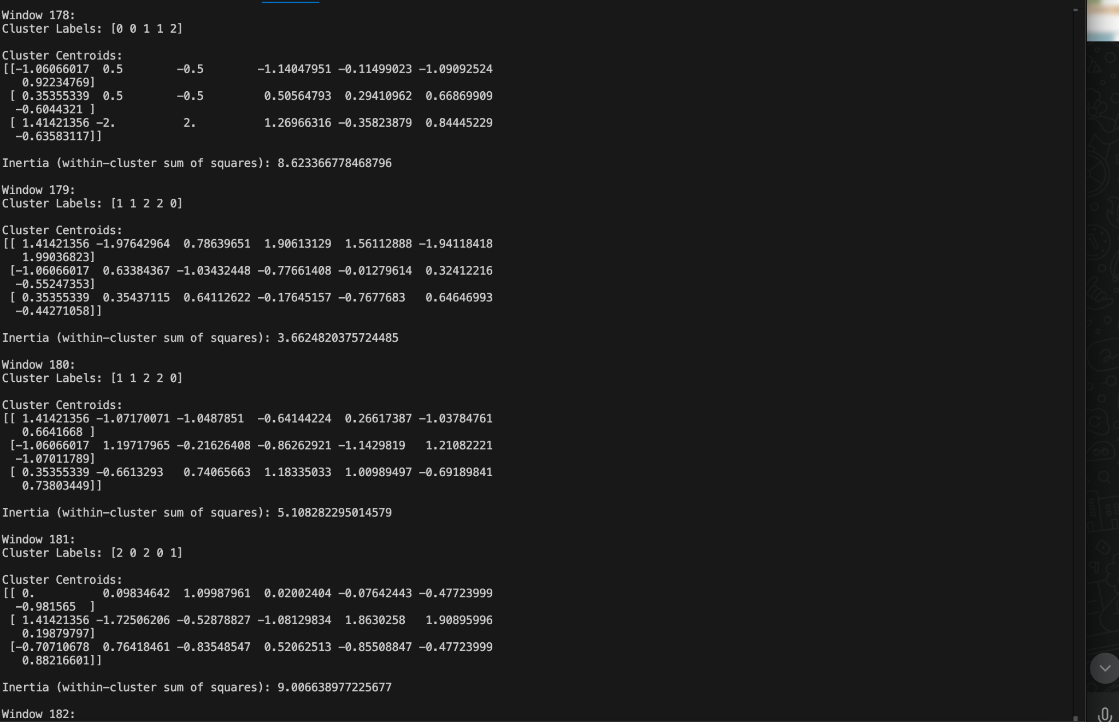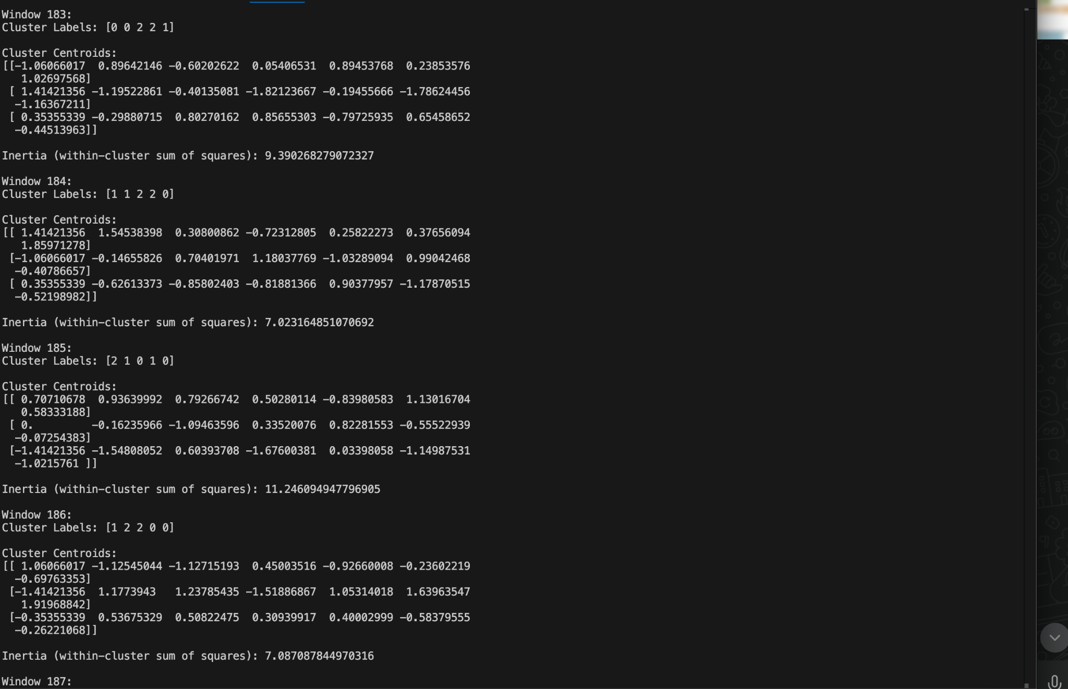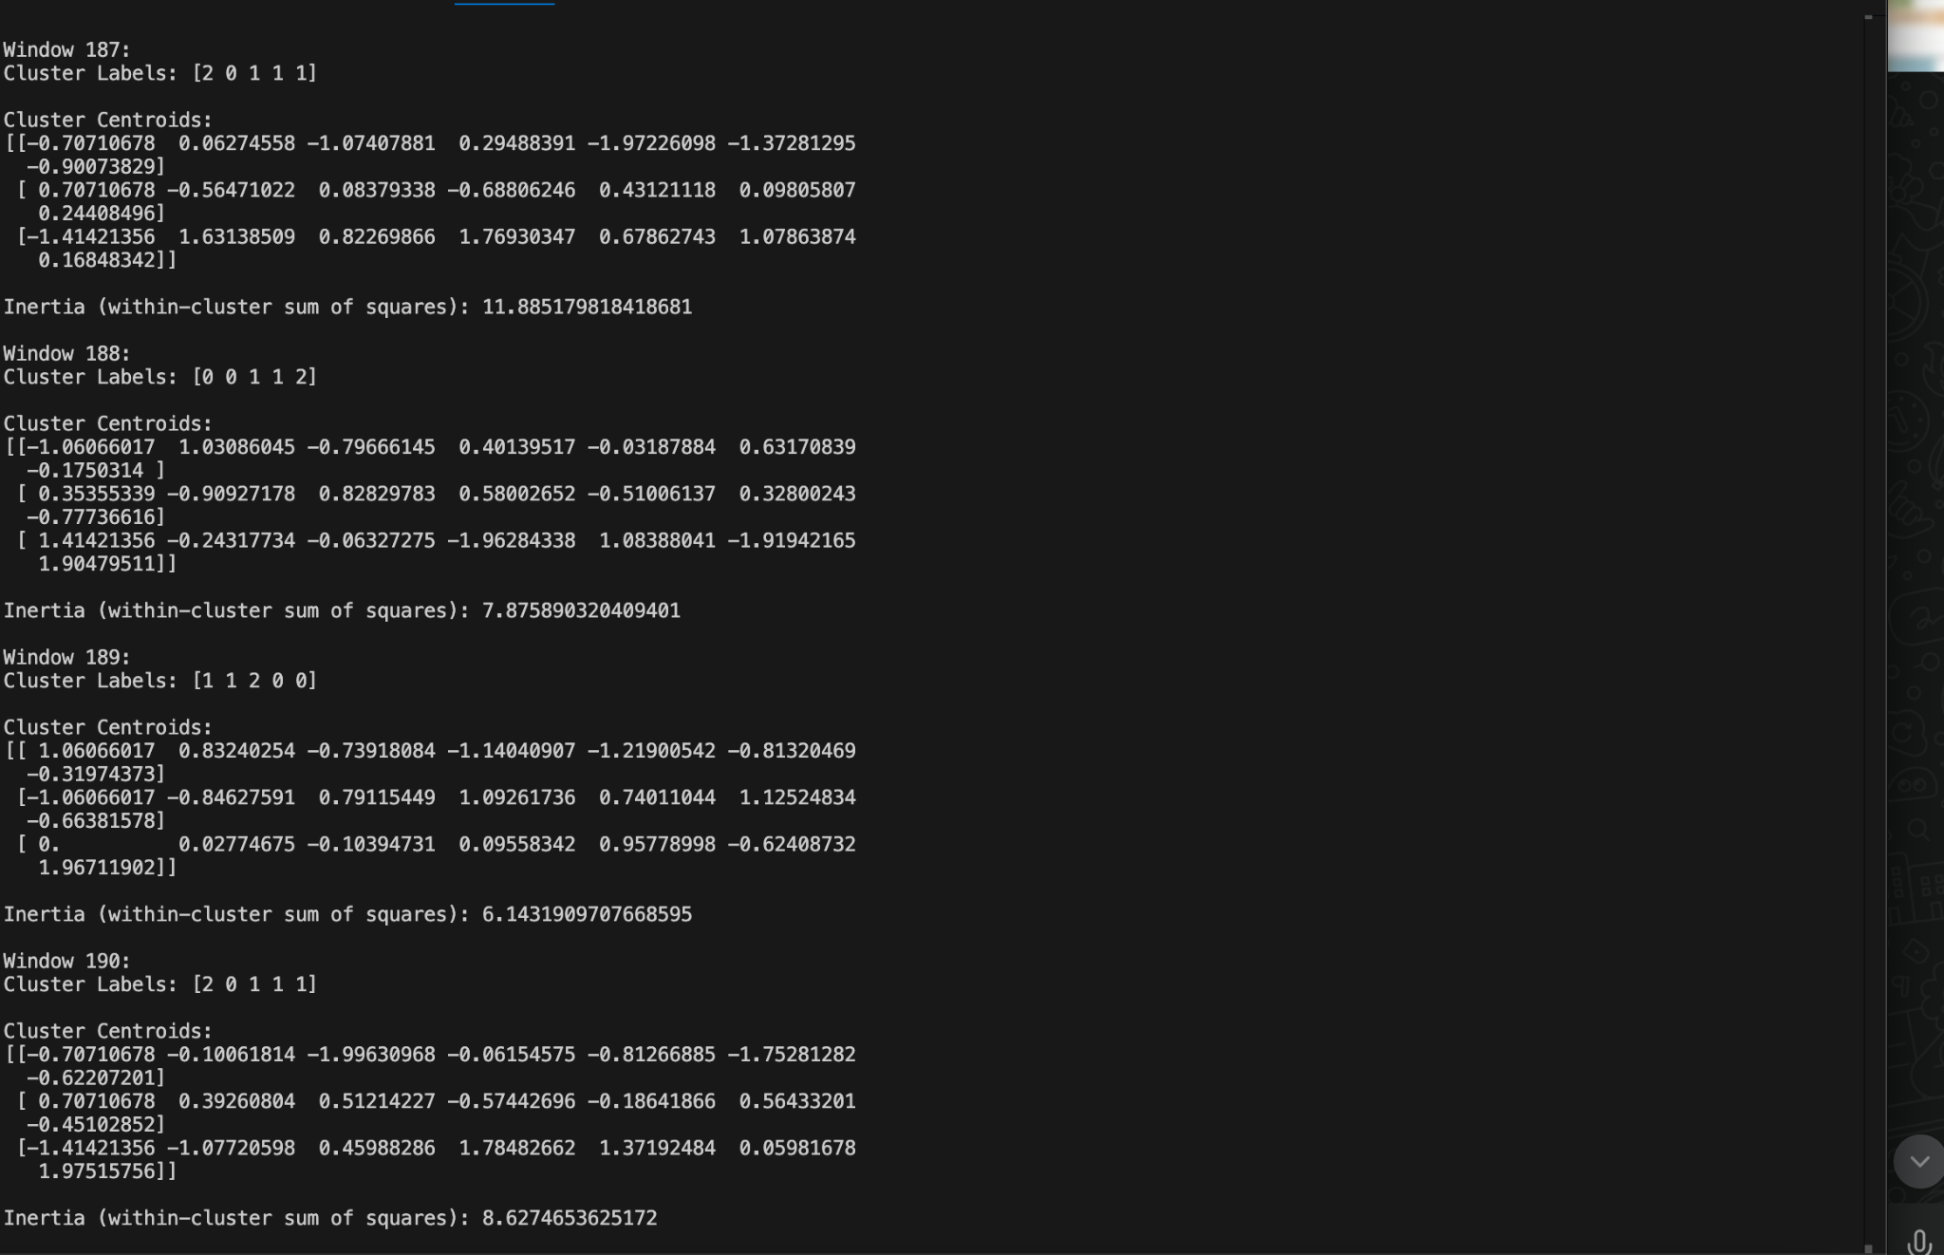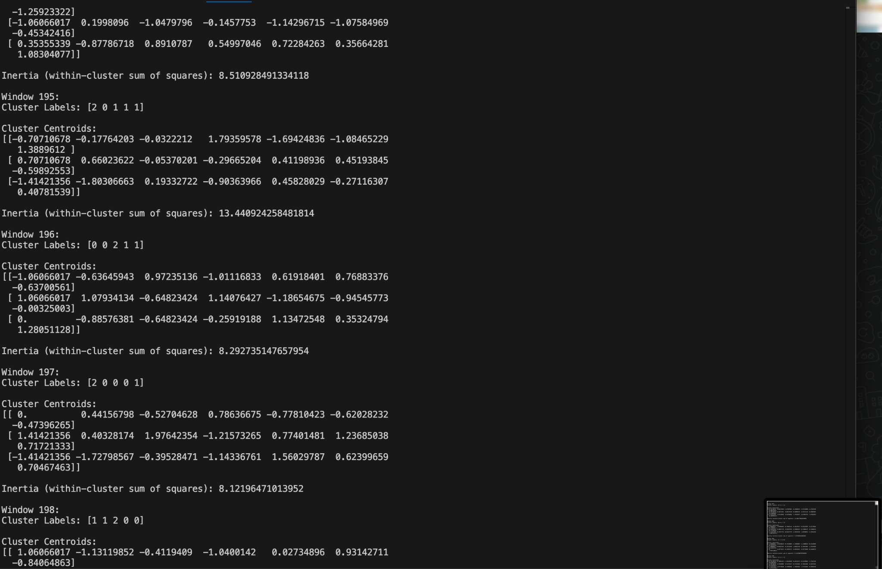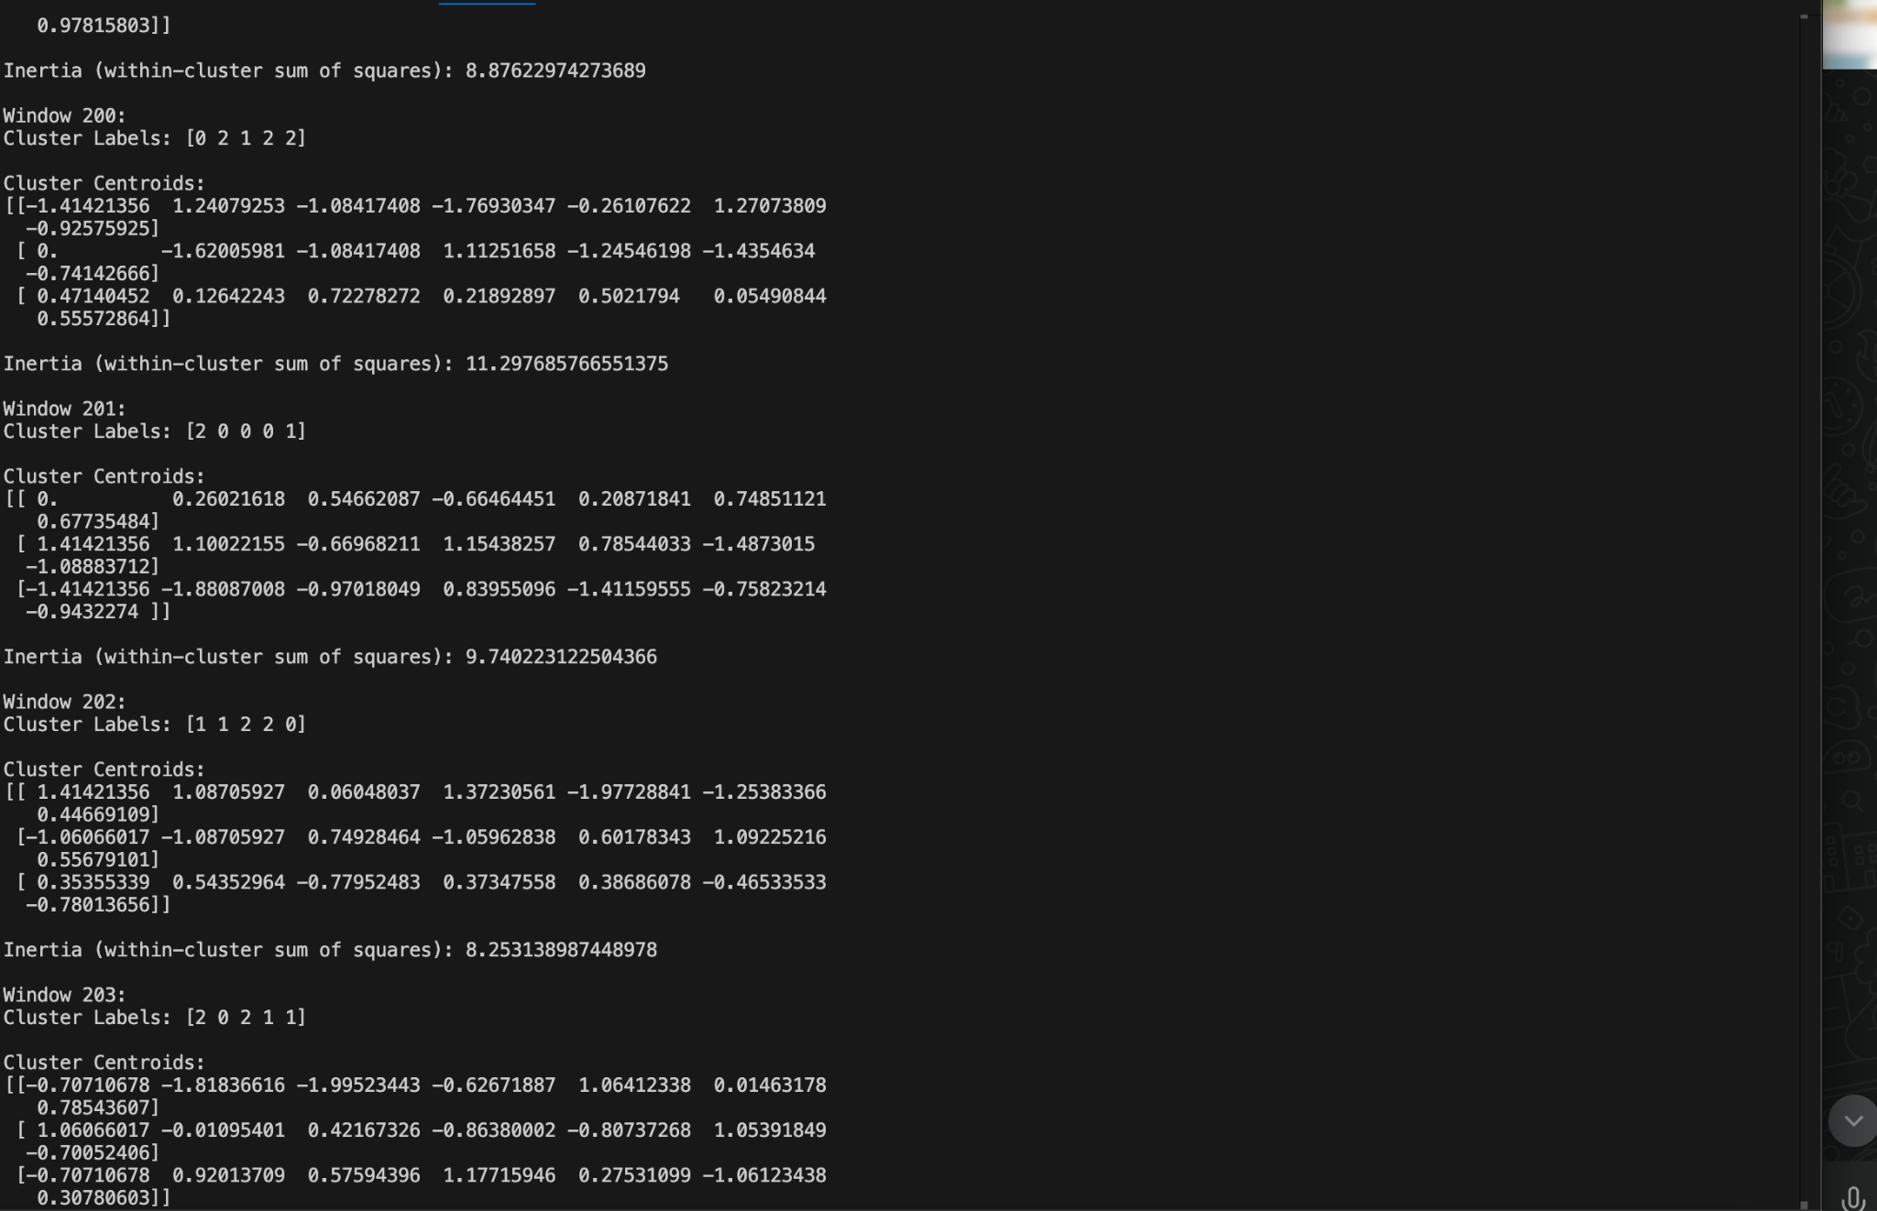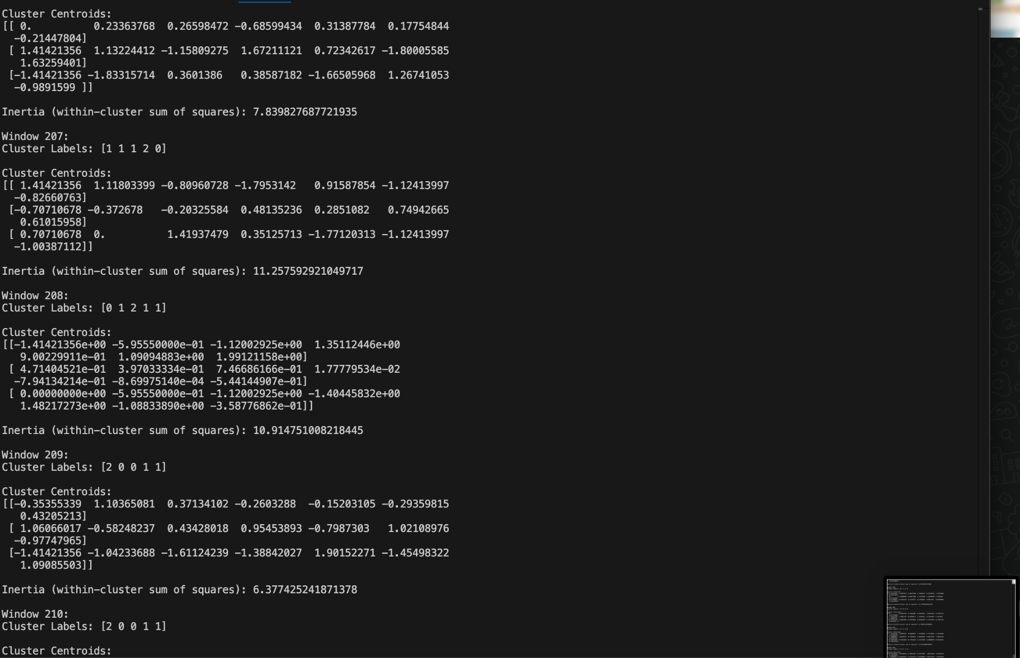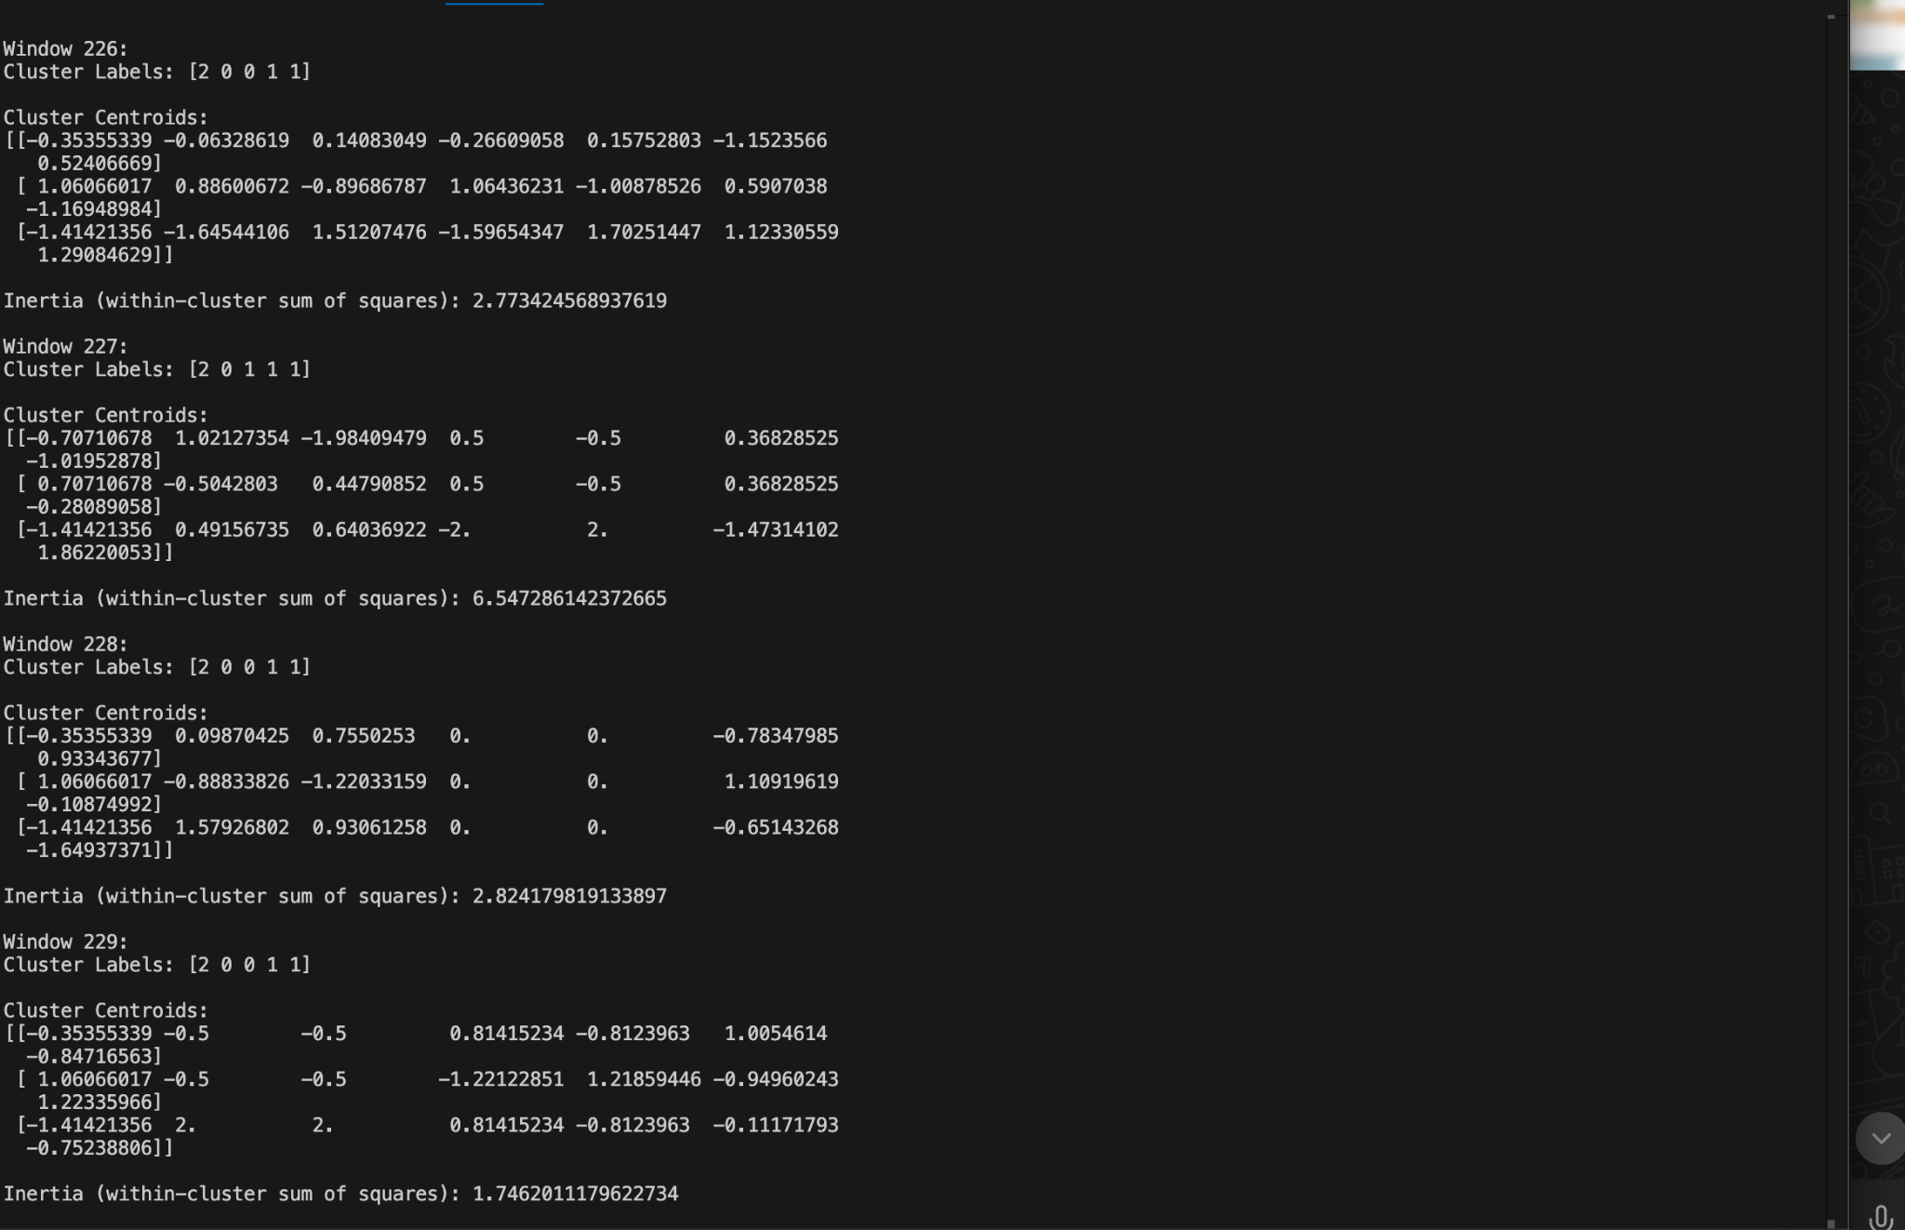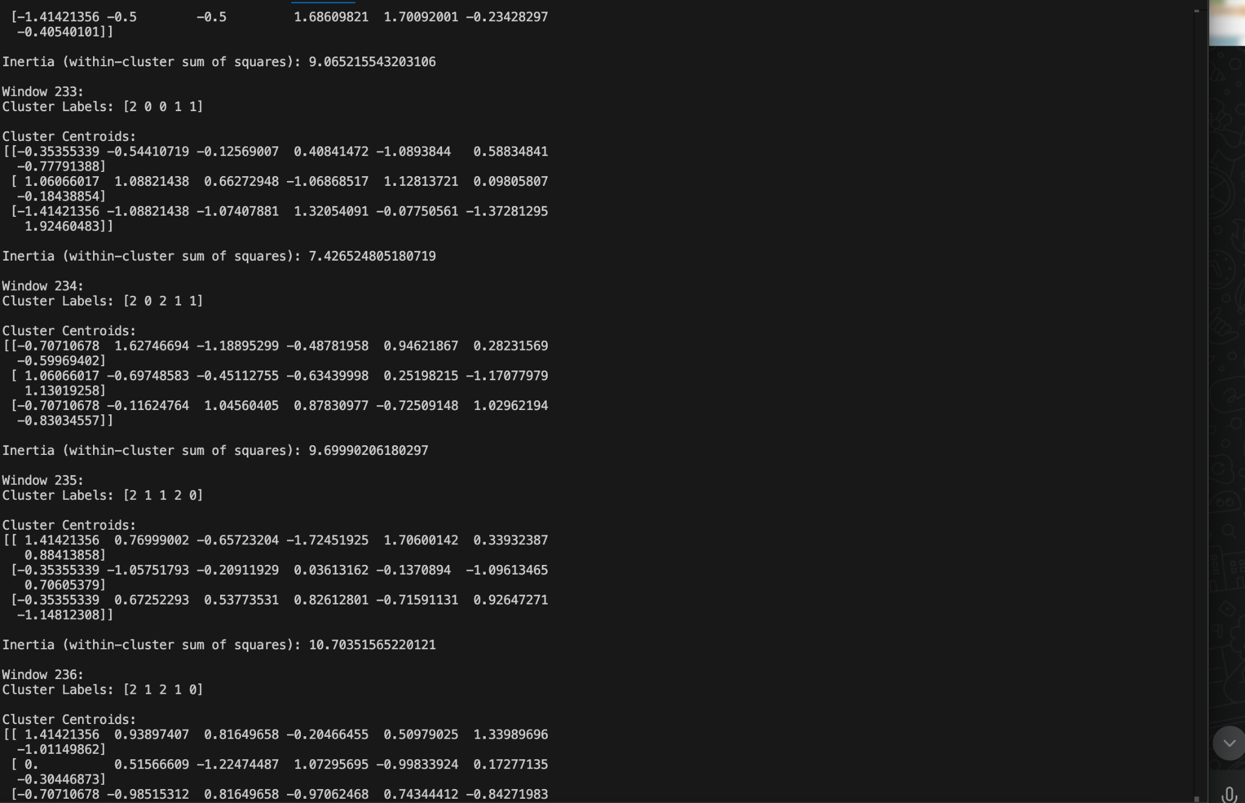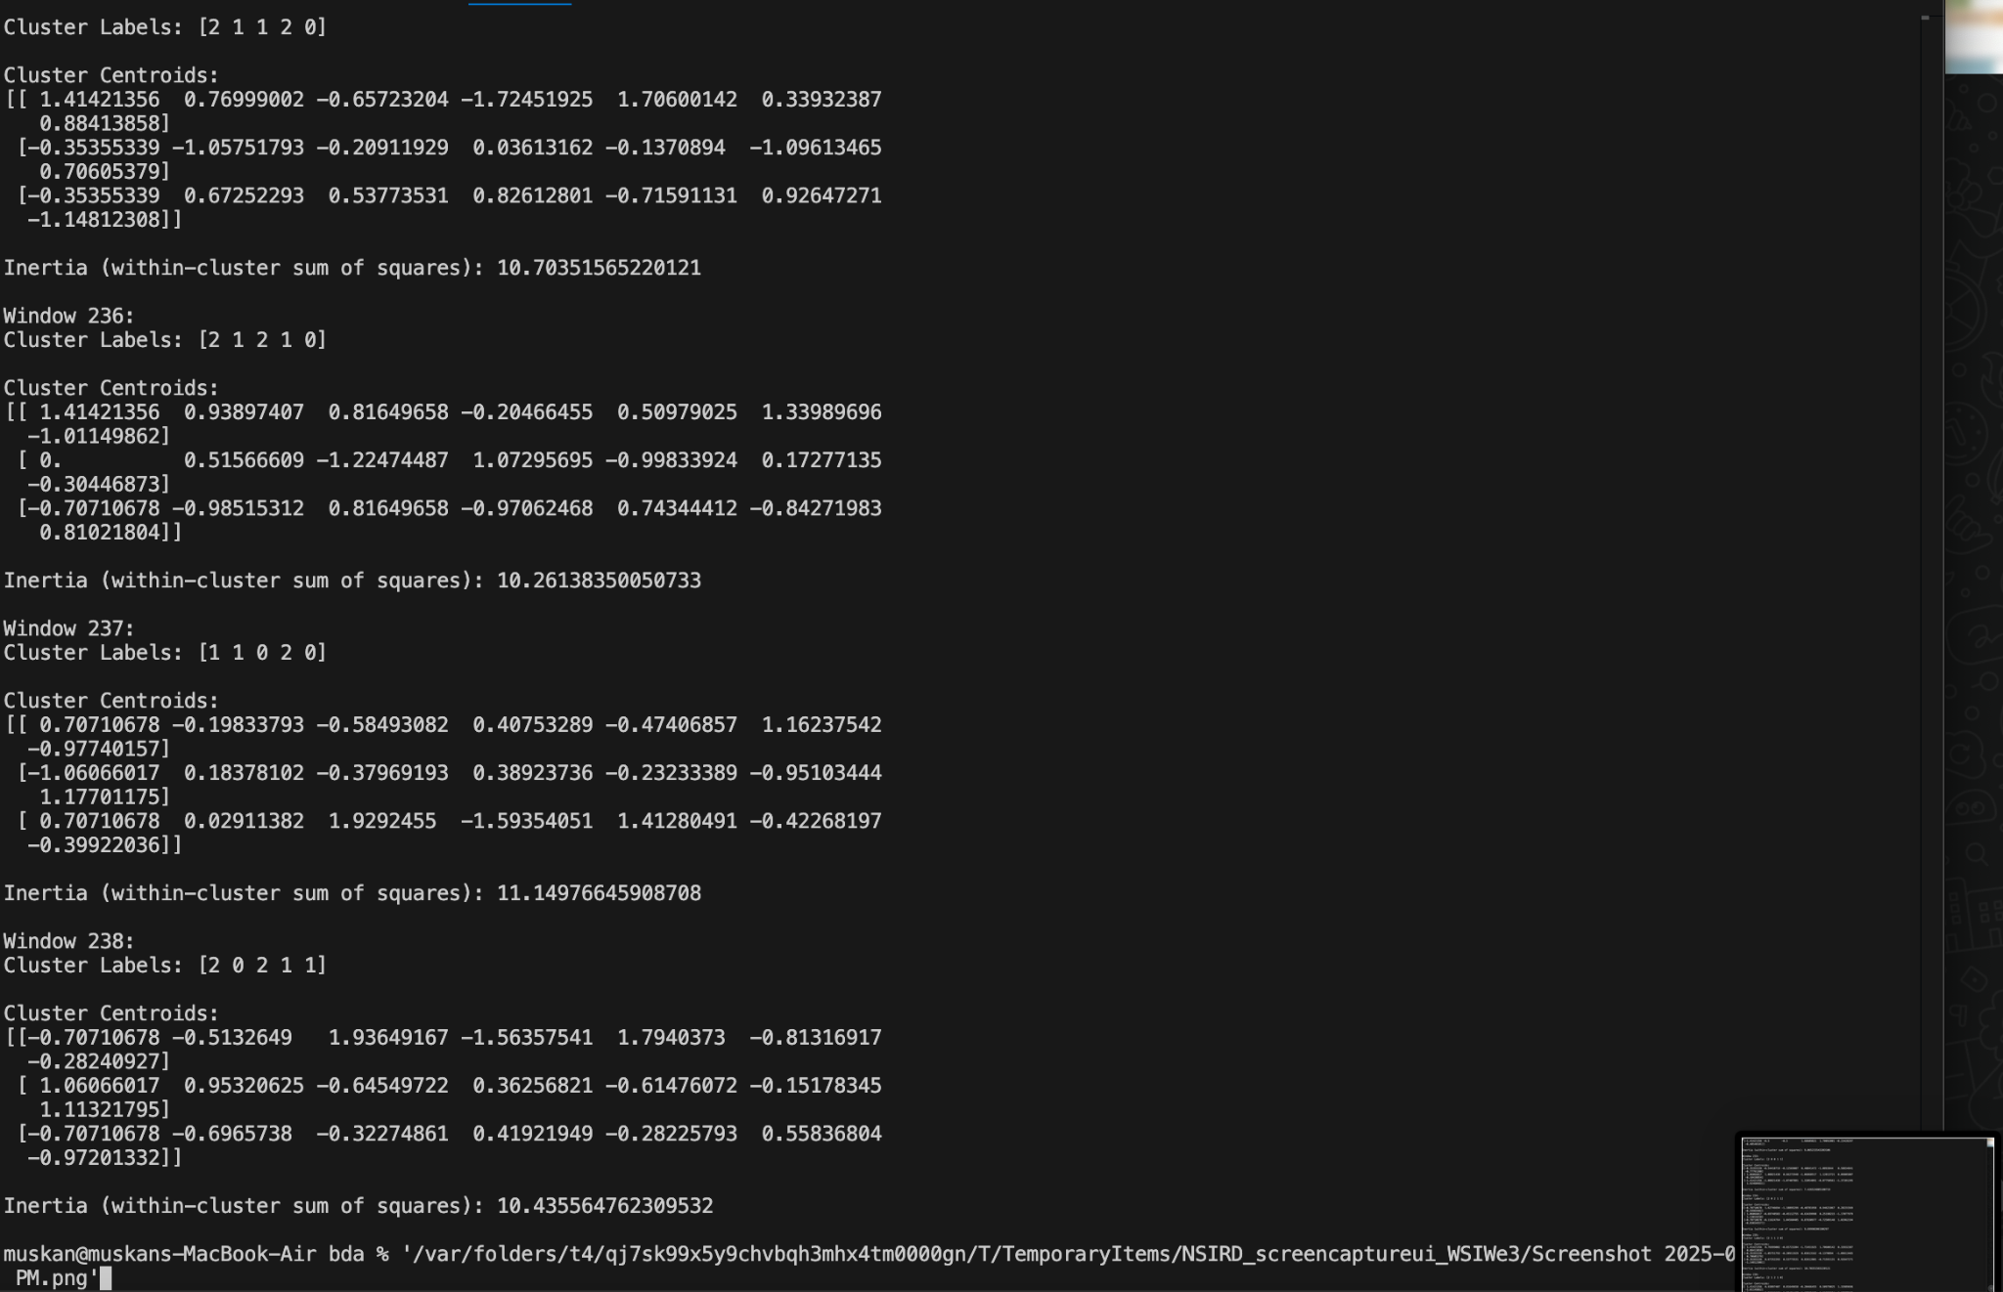

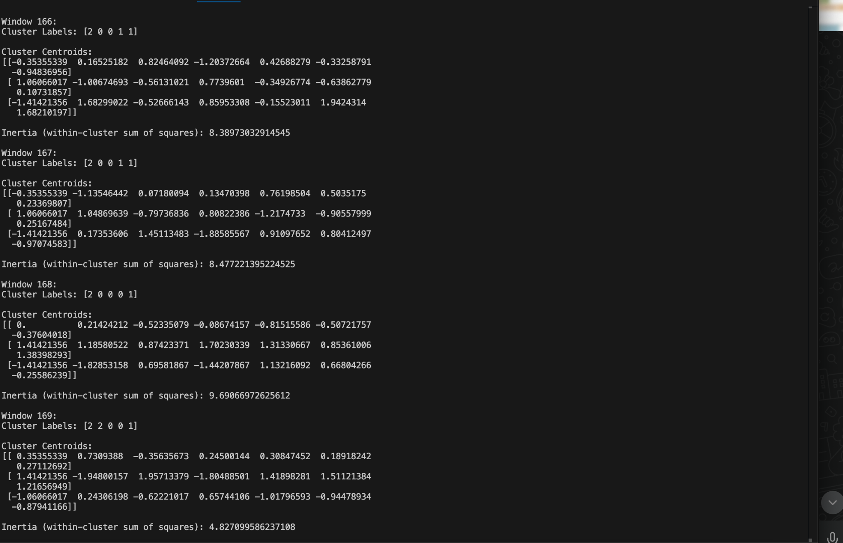

**PLOT** 